COUNCIL ASSESSMENT REPORT

Panel Reference | PPSSEC-70
DA Number | DA/249/2020
LGA | Randwick City Council
Proposed Development | Demolition of existing Block B, construction and replacement of Block B (three storeys), temporary demountable buildings, continued use as an educational establishment, building identification signage, tree removal, landscaping and associated works.
Street Address | 25-45 Donovan Avenue, MAROUBRA NSW 2035
Applicant/Owner | Sydney Catholic Schools (C/O Mr Adoyi Ojobo)/Trustees of RC Archdiocese Sydney
Date of DA lodgement | 4 June 2020
Number of Submissions | Nil
Recommendation | Approval - subject to conditions of consent
Regional Development Criteria (Schedule 7 of the SEPP (State and Regional Development) 2011 | Private Infrastructure and community facilities over $5million – an Educational Establishment with capital investment value of $17,715,511.
List of all relevant s4.15(1)(a) matters | - State Environmental Planning Policy Educational establishment and child care facilities 2017  - State Environmental Planning Policy (State and Regional Development) 2011  - State Environmental Planning Policy No. 55 – Remediation of Land  - Randwick Local Environmental Plan 2013  - Randwick Comprehensive Development Control Plan 2012
List all documents submitted with this report for the Panel’s consideration | - Development Application Assessment Report  - Architectural documentation - Plans, Elevations, Sections and 3D images/photomontages  - Landscape Plans and Details (4)  - Erosion & Sediment Control Plan and Detail (2)  - External Works Plan and Details (2)  - Construction Notes  - Flood Report  - Acoustic Report  - CPTED Report  - Arborist Report  - Hazardous Material Report  - Amended Preliminary Site Investigation Report  - Survey Plans (2)  - Statement of Environmental Effects  - Additional Material Response to DEP comments (2)  - Revised Floor levels and north façade explanation
Clause 4.6 requests | - No Clause 4.6 Variations
Summary of key submissions | - No submissions
Report prepared by | Louis Coorey, Senior Development Assessment Officer
Report date | 5 May 2021

Summary of s4.15 matters  Have all recommendations in relation to relevant s4.15 matters been summarised in the Executive Summary of the assessment report? | Yes
Legislative clauses requiring consent authority satisfaction  Have relevant clauses in all applicable environmental planning instruments where the consent authority must be satisfied about a particular matter been listed, and relevant recommendations summarized, in the Executive Summary of the assessment report?  e.g. Clause 7 of SEPP 55 - Remediation of Land, Clause 4.6(4) of the relevant LEP | Yes
Clause 4.6 Exceptions to development standards  If a written request for a contravention to a development standard (clause 4.6 of the LEP) has been received, has it been attached to the assessment report? | Not Applicable
Special Infrastructure Contributions  Does the DA require Special Infrastructure Contributions conditions (S7.24)?  Note: Certain DAs in the Western Sydney Growth Areas Special Contributions Area may require specific Special Infrastructure Contributions (SIC) conditions | Not Applicable
Conditions  Have draft conditions been provided to the applicant for comment?  Note: in order to reduce delays in determinations, the Panel prefer that draft conditions, notwithstanding Council’s recommendation, be provided to the applicant to enable any comments to be considered as part of the assessment report | No

SECPP No.: | PPSSEC-70
DA No.:  Subject site:  Description: | DA/249/2020  25-45 Donovan Avenue, MAROUBRA NSW 2035  Demolition of existing Block B, construction and replacement of Block B (three storeys), temporary demountable buildings, continued use as an educational establishment, building identification signage, tree removal, landscaping and associated works.
Applicant: | Sydney Catholic Schools (C/O Mr Adoyi Ojobo)  PO Box 217, LEICHHARDT NSW 2040
Report By: | Louis Coorey - Senior Environmental Planning Officer – Randwick City Council

- Executive Summary

Council is in receipt of a development application seeking approval for works to the Champagnat Catholic College involving demolition of the existing building B, construction of a new building B, associated works and installation of demountable temporary buildings at the north eastern corner of the site adjacent to Walsh Avenue. The application was the subject of amendments raising the ground level, with no increase in the height, due to potential flooding in a 1 in 500-year storm event which applies to sites identified as critical infrastructure such as schools.

The Applicant states the proposal does not result in any net increase in students or staff numbers, noting the applicants SEE states it caters for 700 students and 70 full time equivalent staff.

The development is identified as a Regionally Significant Development and referred to the Sydney Eastern City Planning Panel (SECPP) for determination as it involves an Educational Establishment with works having a capital investment value in excess of $5 million, Pursuant to Section 4.7, of the Environmental Planning and Assessment Act 1979 and Schedule 7 of the State Environmental Planning Policy (State and Regional Development) 2011.

The subject application (original proposal) was advertised and notified from 17 June 2020 through to 1 July 2020 in accordance with Council’s Community Participation Plan. As a result of the notification process, no submissions were received by Council. Amendments to the scheme were internal and did not warrant re-notification.

The subject site is zoned SP2 – Educational Establishment under Randwick Local Environmental Plan 2012 (RLEP 2012). The proposal remaining an Educational Establishment is consistent with the zoning objectives. There are no applicable development standards for the subject site, notwithstanding the proposed development is considered to be consistent with the objectives of the height and FSR standards of the surrounding area.

As the proposal is for alterations and additions to a school inclusive of a new building and demountable buildings, the provisions of State Environmental Planning Policy (Educational Establishments and Child Care Facilities) 2017 apply. The proposal is considered to satisfy the design quality principles set out in Schedule 4 of the SEPP and the relevant clauses pursuant to Part 4 of the SEPP.

Due to the development being 15m in height, it is subject to clause 6.11 of the RLEP 2012, which requires the development to exhibit design excellence. As such, the application was referred to Randwick Design Excellence Panel (DEP) for review and recommendations. The DEP requested a master plan that guided the future development of the site, concerns regarding functionality, the placement of the large Building B at the northern end of the site causing overshadowing of the open quadrangle to the south and in terms of Aesthetics the “defensive” enclosed northern elevation.

In response, the applicant submitted additional details further referred to the panel for comments. The DEP acknowledged the additional information submitted to Council and reiterated the concerns with the folded architectural walls along the northern façade in terms of its scale and relationship with the street and the low-density character of the opposite low density zone containing smaller scaled dwelling houses.

The applicant submitted further documentation providing a series of views from Donovan Avenue at eye level, a plan showing the 34% percent of glazing across the northern façade, and elevations showing more clearly the stepped building elements behind the folded architectural walls that sit at level 1 and 2 and that glazing that sits behind perforated semi-transparent metal screens will provide a combination of shading, internal light and views outwards.

The amended plans also included raised internal ground floor level responding to the higher overland flow and flood protection levels associated with 1 in 500-year storm event, applying to critical infrastructure such as schools.

The applicant’s response to the DEP and Development Engineering comments are considered to have appropriately satisfied the relevant design quality principles under SEPP Educational Establishments.

With respect to the applicants responses to the matters raised during the assessment of the proposed development, it is considered that the additional and amended details provided have appropriately addressed the relevant matters for consideration such that the design of the development particularly along its northern elevation facing Donovan Avenue is a functional response to the use of the adjacent internal spaces and it is an appropriately articulated, scaled and integrated series of façade elements with an integrated base, middle and top which is in accordance with the design principles of the SEPP Educational Establishments and will replace a dated building with a contemporary built form that will contain positive qualities within the sites setting.

With respect to the amenity impacts, the proposed development will not contribute to any unreasonable adverse impacts in regard to visual amenity, overshadowing - noting no residential properties to the south, and suitable solar access will be maintained to the open recreation areas orientated to the interior of the site.

Council’s Section 7.12 Development Contributions Plan applies to the proposal and a monetary levy of $177,155.11 is required.

The proposal satisfies the matters for consideration under Section 4.15 of the Environmental Planning and Assessment Act 1979 and is recommended for approval subject to the recommended conditions.

- The Proposal

This proposal is for the demolition of a two-storey block B, and the replacement of block B with a two and three storey building, accommodating a resource centre, seminar rooms and canteen on the ground floor. On the first floor five general learning areas with tiered learning, common breakout spaces and seminar rooms, and on the second floor five general learning areas, a senior common area and amenities with a balcony.

The application also seeks to build demountable buildings to the north east of the site for temporary accommodation during construction.

The proposal also seeks to install building identification signage, remove trees, install new landscaping and also carry out associated works.

- Amended plans

Received on 20 January 2021 in response to Development Engineering issues that the use of the site as a school means that it falls into the category of critical infrastructure and therefore required to be sited at an appropriate level with regards to a major 1 in 500-year storm event pursuant to part B8 Water Management policy controls in the RDCP 2013. Additional material including 3D images, glazing facade analysis, landscaping to address the Design Excellence Panel comments and Schedule 4 Design quality principles in the SEPP Educational Establishments.

- The Subject Site and Surrounding Area

The subject site known as 25-45 Donovan Avenue, Maroubra is legally identified as Pt Lot 5089 and Lot 1 in DP 653398 covering an area of 1.6ha and is irregular in shape bounded by street frontages to the north to Donovan Avenue, to the east to Walsh Avenue, to the south to Fitzgerald Avenue and Bunnerong Road and to the west to Parer Street. A cadastral and aerial view of the site is shown in Figure 1 below.

The aerial view below identifies that the site is occupied by Champagnat Catholic College, Our Lady of Annunciation Catholic Primary School and Our Lady of Annunciation Church, presbytery and brothers’ residence. The particulars of this application relating to Buildings B and the north eastern corner of the Champagnat College specifically the demolition of existing Building B, construction of a new building B and demountable temporary buildings during the works phase are located in No 35E Donovan Avenue Pt Lot 5089 DP 653398 comprising buildings A to G. It is noted that No. 35E Donovan Avenue fronting Donovan Avenue is an informal non-cadastral parcel. The proposed demountable buildings are proposed towards the north eastern corner of the site identified in orange outline in the aerial image below.

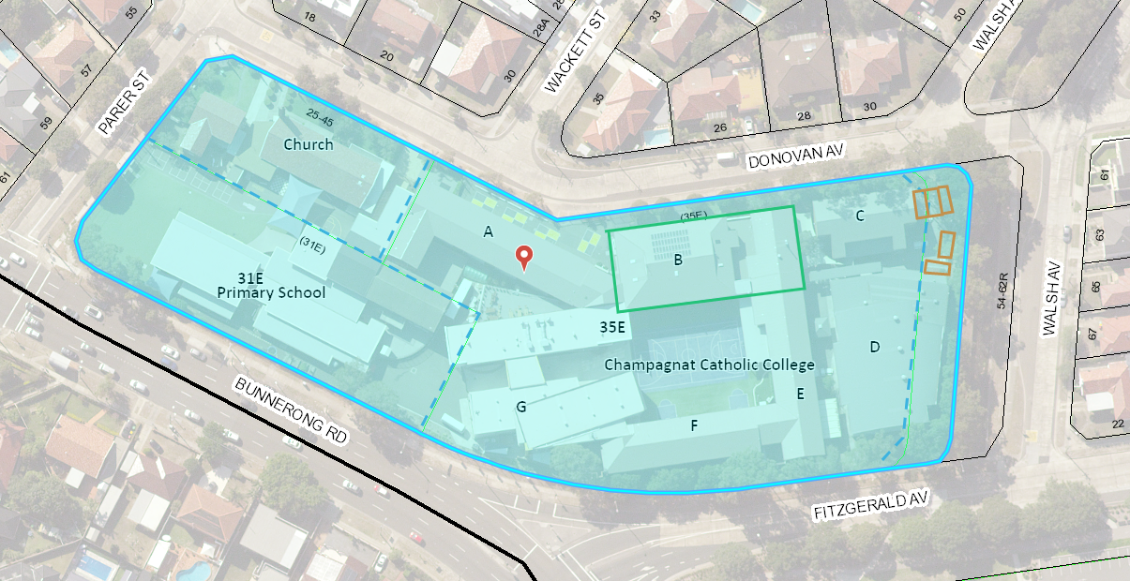
Figure 1: Aerial and cadastral view of subject site showing location of building b and proposed location of temporary demountable buildings (classrooms, canteen and WC).

Site photos below show Building B as it sits along Donovan Avenue and within the school grounds.

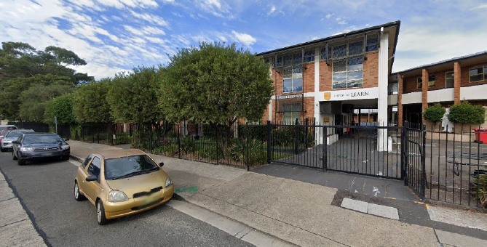
Photo 1: Building B looking southward from along Donovan Avenue (Source: Robinson Urban Planning)

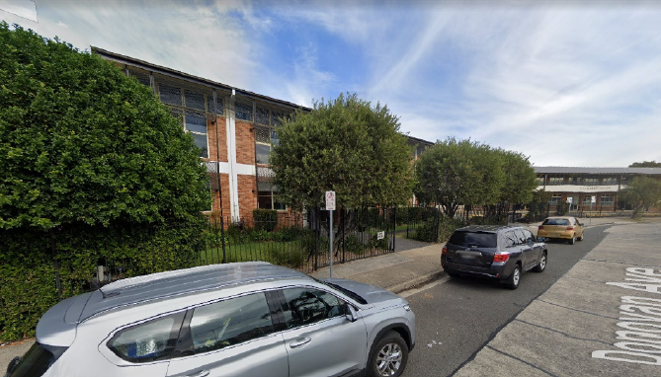
Photo 2: Building B as viewed from along Donovan Avenue looking westward. Building A in background at right of photo (Source: Robinson Urban Planning)

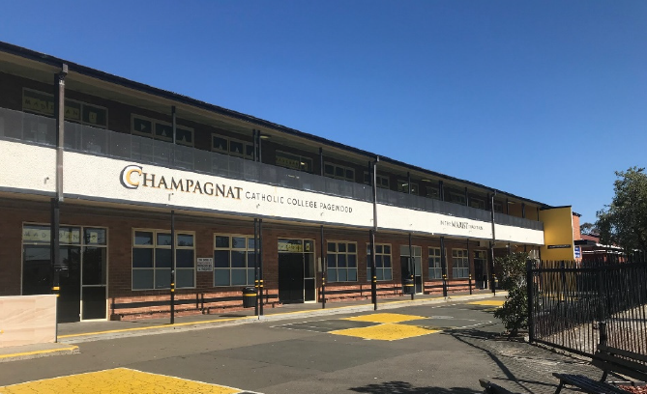
Photo 3: Building B from within the school grounds (Source: Robinson Urban Planning)

The subject site is zoned SP2 for the purpose of an Educational Establishment pursuant to RLEP 2012. The site is surrounded by R2 zoned low density residential developments to the north, east and west, with land to the south on the opposite side of Fitzgerald Avenue and Bunnerong Road Heffron Park zoned RE1 Public Recreational. See zoning uses overlayed onto the aerial image below.

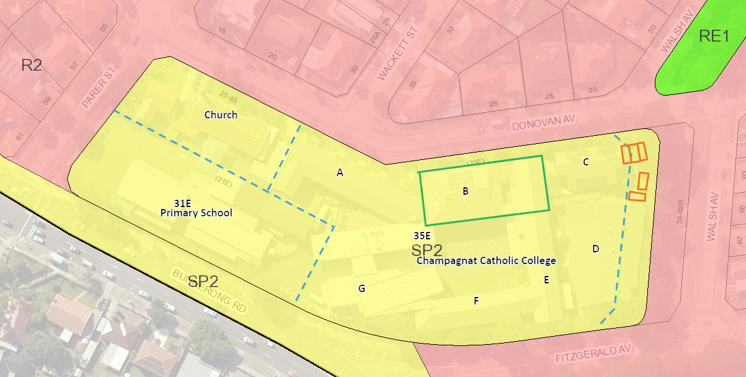
Figure 2: Zoning map and aerial view

- Site History

The site has been used as an Educational Establishment, being a School for a significant period with applications dating back to 1964 for the school and 1957 for a church hall. The Champagnat school formerly known as Marist Brother Pagewood and Marist College Pagewood has occupied the subject site for around 50 years. The site has been subject to numerous development applications. A search of Council’s records revealed the following recent and/or relevant applications for the site.

CDC/197/2019
Alterations and additions to existing school building (Block A) a 2-storey building and associated external works. Issued pursuant to Division 5 Complying Development in SEPP Educational Establishments and child care facilities.

CDC/109/2019
Conversion of existing building (Block B) into eight (8) new temporary General Learning Areas and Block E deck space to be converted into a permanent General Learning Area. Issued pursuant to Division 5 Complying Development in SEPP Educational Establishments and child care facilities.

PL/49/2019
Pre-DA application for construction of new building (Block B) at Champagnat Catholic College and installation of demountable buildings. A meeting was held with the applicant identifying key issues associated with the proposal noting SEPP Educational establishments, requirement for waste management plan, on site stormwater retention, Design excellence panel may be sought with a future DA and Clause 6.12 Development requiring the preparation of a development control plan may be applicable. Note: cl 8(2) of SEPP Educational Establishments and child care facilities specifically excludes the application of cl 6.12 of the Randwick Local Environmental Plan 2012.

Subject Development Application DA/249/2020
The subject application was lodged with Council on 4 June 2020. The application was externally referred to RMS who rejected the application and did not wish to make comment. The application was referred internally within Council to Council’s Development Engineer, Environmental Health Officer, Landscape Officer, Senior Building Surveyor, Community Development Officer and Randwick Design Excellence Panel.

Randwick’s Development Engineer identified the school use as critical infrastructure and was therefore subject to Part B8 Water Management requiring consideration of the 1 in 500-year flooding event. Subsequent plans were received as noted below raising the internal ground floor level with no change to the 15m building height as originally proposed.

- Community Consultation

The subject development was notified to surrounding landowners for a period of fourteen (14) days between 17 June 2020 and 1 July 2020 in accordance with Council’s Community Participation Plan. No submissions were received as part of the notification process.

- Technical Officers Comments

The application has been referred to the relevant technical officers, including where necessary external bodies and the following comments have been provided: -

- Development Engineer and Landscape Officer

The application was referred to Council’s Development Engineer for comment and recommendations who provided the following advice in relation to the amended proposal:

- Development Engineer

An application has been received for the demolition of existing Block B, construction and replacement of Block B (three storeys), temporary demountable buildings, continued use as an educational establishment, building identification signage, tree removal, landscaping and associated works.

This report is based on the following plans and documentation:
- Amended Architectural Plans by QOH Architects, dwg’s DA1000-2970, rev 04, dated 23/12/20;
- Statement of Environmental Effects by Robinson Urban Planning stamped 4th June 2020
- Detail & Level Survey by Hill & Blume date 9th May 2018
- Arboricultural Impact Assessment by ArborSafe, dated 21/01/20;
- Landscape Plans by OHD Landscape Architects, dwg’s DA2800-2803, issue B, dated 23/04/20.

General Comments
No objections are raised to the proposal subject to the comments and conditions provided in this report.

Flooding Comments
The site lies within the catchment for the ‘Birds Gully Flood Study’ which predicts flooding of the site during the PMF (probable Maximum flood) storm event. The site is unaffected by flooding during the 1% AEP (1 in 100yr flood).

Sec 5 Part B8 of Council’s DCP states that schools are classified as a “critical facility” and accordingly in Table A specifies that floor levels must be provided as per the following;

Habitable Floor – (Critical Facility)

- Inundated by flooding – PMF (Probable Maximum Flood) + 0.5m freeboard

Council’s flooding software indicates significant flood depths on the property for the PMF flood, with a top water level of around RL 21.24 AHD. The resulting minimum flood planning level would therefore be RL 21.74 AHD based on the above DCP requirements for critical facilities.

The proposed ground floor level of the development was initially proposed as RL 20.57 AHD, being 1.17m below the flood planning level, hence the application was not initially supported.

There are some individual circumstances with this application however which prevent it from being able to comply with the flood planning level, namely the practical need to match the exiting playground/basketball court levels on the southern side of the building. The DCP flood planning level of RL 21.74 AHD would be virtually impossible to achieve when considering aspects such as disability ramp access.

A time step analysis of flood behaviour indicates that during the PMF Event it will take approximately 1hr 40 mins to reach the peak water level of RL 21.24 AHD. This does allow a satisfactory amount of time for evacuation of the ground floor to the floors above. It was also noted that after 1 hour the top water level during the PMF Flood event will be around RL 20.89 AHD. It is therefore considered that a flood planning level of RL 20.9 can be adopted being the approximate level of the PMF after 1 hour. This is 0.33m higher than the initially proposed floor level and will still allow sufficient time for evacuation during the PMF event while also providing practical access to the playground tennis courts.

The amened plans received 20th January 2021 demonstrate compliance with this requirement. Ramps are also now provided (grade of 1:20) on the southern side to provide disability access.

The amended plans comply with Development Engineering requirements and the application is now supportable from a flood perspective. A condition has been included about having an evacuation procedure in terms of flooding in any plan of management.

Drainage Comments
The Planning Officer is advised that the submitted drainage plans should not be approved in conjunction with the DA, rather, the Development Engineer has included a number of conditions in this memo that relate to drainage design requirements. The applicant is required to submit detailed drainage plans to the Principal Certifier for approval prior to the issuing of a construction certificate.

The stormwater must be discharged (by gravity) either:

- Directly to the kerb and gutter in front of the subject site in Donovan Avenue; or

- Directly into Council’s underground drainage system located on the opposite side of Donovan Avenue Donovan Avenue ; o

- To a suitably designed infiltration system (subject to confirmation in a full geotechnical investigation that the ground conditions are suitable for the infiltration system),

Should the Stormwater be discharged to Council’s street gutter or underground drainage system, an onsite stormwater detention (OSD) system will be required for this development.

Parking Comments
As there is no proposed increase in student or staff numbers additional parking is not required and there is no need to for a traffic and parking report.

It appears the proposed elevations indicate the existing vehicular access from Donovan Avenue in front of the development is proposed to be removed although this not been explicitly stated in the SEE or shown on the plans. As the implications of such a removal for vehicle access (including service vehicles) have not been investigated or addressed in the SEE, it removal is not supported

The access appears to be still being used as it provides access for service vehicles and off-street parking on occasion.

Undergrounding of site feed power lines
At the ordinary Council meeting on the 27th May 2014 it was resolved that;

Should a mains power distribution pole be located on the same side of the street and within 15m of the development site, the applicant must meet the full cost for Ausgrid to relocate the existing overhead power feed from the distribution pole in the street to the development site via an underground UGOH connection.

The subject is not located within 15m of a power pole on the same side of the street hence the above clause is not applicable.

Waste Management Comments
The applicant is required to submit to Council and have approved by Council’s Director Planning, an amended Waste Management Plan (WMP) detailing waste and recycling storage and disposal for the development site.

The plan shall detail the type and quantity of waste to be generated by the development; demolition waste; construction waste; materials to be re-used or recycled; facilities/procedures for the storage, collection recycling & disposal of waste and show how the on-going management of waste for the redeveloped portion of the site (including the canteen) will operate.

- Landscape officer

Tree Management Comments
This site was inspected on 2 December 2020, with a detailed Arborist Report that has assessed a total of 28 trees having been submitted in support of the application, with only 11 trees sought for removal so as to accommodate the works, with the Landscape Plans showing that suitable like-for-like replacements will be provided in their place.

The only Council trees on public property are the row of three 5-6m tall Bottlebrush’s within the Donovan Avenue verge, between the two existing laybacks, directly opposite Wackett Street, which despite being well clear of the access points and works (so have not even been assessed in the Arborists Report), minimal protection conditions have still imposed in order to prevent damage by secondary impacts such as from trucks, deliveries and similar. The larger Coastal Banksia’s further to their west are well away from all works, so will not be affected.

To the southeast, within the subject site, along the front boundary, on either side of the pedestrian entry to the existing Block B, are a row of three more Bottlebrush’s (T1-3), along with some smaller shrubs, and then at the eastern end of this group, a Hibiscus (T73), a Willow Myrtle (T74) and another Bottlebrush (T75).

While as a group they assist with both presentation and separation, none are significant in anyway, so a major re-deign of the whole proposal to retain them is not warranted, as all have been assigned ‘a Low Retention Value’, and are also in direct conflict with the footprint of the works, suffering major encroachments of their TPZ’s. As such, conditions allow their removal and replacement with a row of 5 x advanced Coastal Banksia’s in the landscape zone shown for this same area, between the new building and boundary.

The group of other native/endemic trees (T72-67) just to their east, adjacent Block C, can all be retained, due either to their location closer to the front boundary, or, distance from the new works, with protection conditions in this report adopting the Recommendations of the Arborists Report.

No objections are raised to removing the other Broad Leafed Paperbark (T66), between the existing Building’s B & C, as shown and as recommended, as it will be heavily affected by the new footprint, with insufficient space to re-design around it, along with T64, due to being unsafe, irrespective of this development, as well as T63-62 & 60, around the northeast site corner so as to allow for the works, with the 6 advanced native replacement canopy trees to be installed back in this same area following removal of the demountable building deemed to provide adequate compensation for their loss.

The ability to safely retain this sites most significant tree, a Moreton Bay Fig (T58) right in the northeast site corner, along with T61, will ensure that reasonable levels of environmental amenity are maintained at this prominent corner location into the future.

There is another group of established native trees along the length of the Walsh Street frontage, adjacent Block D, including T57-55, 53-51 & 49, which with the exception of T54 which requires removal; can all be retained in-situ, with conditions formally requiring that the temporary buildings in this area be placed above grade, which is feasible and reasonable within the scope of these works, as this will maintain a strong ’green presence’ along this streetscape, particularly as many other trees will be lost elsewhere throughout the site so as to allow for the development.

All other trees further to the southwest, fronting Fitzgerald Avenue, adjacent Block F, G and the Primary School, have not even been assessed by the Arborist Report as there are no works in these areas that would threaten the trees in anyway.

- Environmental Health Officer

Randwick’s Environmental Health Officer requested a Preliminary Site investigation report which was promptly provided by the application for further review. The following comments were provided:

Proposed Development:

Application has been received to demolish Block B of the Champagnat College located at the subject address. The application entails the re-construction of a new 3 storey Block B for educational purposes together with landscaping, site works, temporary demountable buildings, and a new canteen.

Comments:

The proposal is located within the groundwater embargo area and SEPP 55 was not addressed initially. A PSI was submitted for review with this application. In accordance with the submitted report, suitably worded conditions will be imposed requiring the waste be classified, an unexpected find protocol be implemented, and all works are undertaken with regard to the relevant guidelines.

An acoustic report will be conditioned to protect the amenity of the nearby residential environment and conditions requiring compliance with the relevant food safety legislation will be recommended.

- Design Excellence Panel

Randwick’s Design Excellence Panel considered the application on 2 occasions as lodged at its meeting in July 2020 and the applicant’s response (planning and architectural response) at its meeting in November 2020 (documentation contained in briefing notes to the SECPP panel). The DEP main concerns initially related to the preference for a master plan to be submitted for the site, Aesthetic presentation to the Donovan Avenue frontage and overshadowing of the quadrangle south of the proposed Building B. The applicant provided a response to the issues raised and contained in the comments provided following design quality principles set out by the DEP.

A final set of amended plans were received by Council on 20 January 2021, raising the ground level in seeking to protect critical infrastructure in a 1 in 500 year storm event, confirmation that the existing fig tree identified as a significant tree is being retained and submission of a design report and CAD model describing the existing northern elevation and explaining why it is an appropriate design response inclusive of details showing the percentage of glazing to solid wall on the northern elevation, showing the northern elevation with trees outlined at mature height, elevation with the proposed screen deleted for the purpose of showing the extent of proposed windows and a series of views from Donovan Avenue at adult eye level.

The amended plans were not required to be reported back to the Design Excellence Panel for comment and/or recommendation due to minimal changes made to the proposal as sought to be justified in the material submitted for the Panels consideration in November 2020.
PANEL COMMENTS
This proposal is for the demolition of a two storey block B, and the replacement of block B with a two and three storey building, accommodating a resource centre, seminar rooms and canteen on the ground floor. On the first floor five general learning areas with tiered learning, common breakout spaces and seminar rooms, and on the second floor five general learning areas, a senior common area and amenities with a balcony.
The application also seeks to build demountable buildings to the east of the site for temporary accommodation during construction.
There was no master plan submitted with the proposal. There are a number of CDC developments which would be relevant to the assessment of this proposal and were not clearly shown in the documents.
The registered architect for the project is QOH architects.
CONTEXT AND NEIGHBOURHOOD CONTEXT
Champagnat Catholic College sits to the north of the intersection of Bunnerong Road and Fitzgerald Avenue, to the south is Heffron Park, to the north individual dwelling houses, to the west our Lady of The Assumption church, Presbytery and brothers residence and to the east a storm water channel, Walsh Avenue and dwelling houses.
SCALE AND BUILT FORM
The Panel would like to see the master plan that is guiding the development of the school over a 5, 10 and 20 years horizon.
In a general arrangement of the site or a master plan drawing the Panel would have expected to see the largest, tallest building to the south of the property overshadowing the intersection rather than overshadowing the main playground area. The placement of the new three storey block B to the north has necessitated the cutting back of the upper level to limit shading to the south and the creation of a south facing covered way with the canteen and access to the resource centre. The orientation of these facilities is not ideal.
The function of the triangular shaped seminar rooms between GLA‘s limit the flexibility of these rooms. These seminar spaces may work better not being embedded in the GLA’s but accessible from them. The lack of flat solid wall surfaces in some of the GLA’s will restrict their use. The Panel noted some smart boards mounted awkwardly on angled walls.
Generally, the way stairs are drawn in this project is confusing. Stairs appear to start in voids and are shown on the level below in plan. Day to day circulation in stair B1 is limited since it egresses to the public area of the site outside the security.
Windows and doors functions should be correctly shown, sliding doors are not fixed glass doors as shown on the plans. The open voids and tiered learning spaces will have a very strong effect on natural ventilation and acoustics. The cross ventilation of GLAs was discussed but not the natural thermal chimney effect of these voids. An east west section through the stairs and voids is required.
The operation of this thermal chimney should be extrapolated with diagrams.
Applicants’ response:
Location of proposed building:
Locating the new building on the southern side of the site would require demolition of block F and E. These buildings contain the following: 8 existing, highly utilised General purpose learning areas (GLA’s) at first floor and 4 GLA’s and two science labs at ground floor. Decommissioning this number of facilities concurrently in a school with an existing deficit of over 2000m² of teaching space and no available surplus outdoor space for provision of this quantity of demountable buildings is not viable. The school would not be able
to operate under such circumstances. Maintaining the school as operational during the construction of the project is a primary requirement of the project.

Overshadowing:

The form of the proposed building has been specifically designed to mitigate increased shadow impact on the existing quadrangle. The shadow diagrams submitted indicate that there is some increased overshadowing of the quadrangle as a result of the new proposal. The increased shadow area impact of the proposed building form on the quadrangle is described in figure 2 below. The percentage of additional area of overshadowing is not significant being between 20% to 37.5% and retaining solar access to parts of the open space between 9am and 3pm during the winter solstice.

The south facing covered way provides a covered passive / recreation and circulation zone between the active quadrangle space and the southern ground floor wall of the proposed building. A covered external circulation loop to the perimeter of a quadrangle space providing external connections between buildings is a standard functional requirement for schools and that is what is provided in this proposal. The proposed design should not only consider the outcome at the winter solstice. This space will provide a valuable shaded outdoor area which will be highly valued from October to March. (6 months of the year)
Location of canteen:
Response: The existing canteen is located within the Block C building to be demolished under this proposal. The provision of a permanent canteen is part of the function brief for this proposal. The brief required the new canteen to be double sided to service the internal ground floor space of the resource centre and to be accessible from the existing quadrangle area. The proposed location of the canteen meets these requirements.
The resource centre has an entry point located on the west elevation, break out space located to the north elevation and, circulation located to the east elevation. Locating the canteen on the southern elevation, adjacent the quadrangle where the majority of students congregate outside of class is the most viable location to permit functions on the other elevations to occur concurrently.
Functioning of seminar rooms
Response: The design of the building and particularly the configuration of the GLAs, learning commons and seminar spaces is the result of approximately 1000 hours of consultation between Architect, Sydney Catholic Schools and school staff. The design has progressed through a 3 tier review process and as a result the client has made an informed decision to accept this design.
The seminar spaces are embedded in the GLAs with a third wall opening onto the learning common so that they are directly accessible to all of these spaces. Direct access and visibility to the adjacent GLA is required for supervision. Refer figure 3 describing the 3D view of the GLA and Seminar space.
Lack of flat, solid wall surfaces in GLAs
Response: The primary teaching wall is provided as a flat solid wall. Refer figure 4 View of teaching wall. The requirement for a smaller, secondary work space is facilitated by the recessed wall located on the northern elevation. The LCD screen proposed to be mounted on the northern elevation would be fixed to an extendable elbow so that they can be moved to be viewed from different parts of the room. The wall profile behind the screen does not affect the mounting of the screen. In any event, there are no urban design or amenity issues arising from this client preference.
Stair drawing is confusing:
Response: Figure 5 shows 3D view of all stairs for clarity. The 3D images are not included in this report as they are not considered necessary.
Stair B1 circulation:
Response: Stair B1 is a required exit under the National Construction Code. Principal circulation stairs are stair B2 and the stairs within the tiered learning areas. These stairs provide ample provision for circulation within the building interior.
Sliding glass doors and windows:
Response: The sliding glass doors are proposed as telescoping construction (except cavity sliders). These doors have a fixed leaf. A 3D view of the proposed sliding doors is described in figure 3.
Cross section through voids:
Response: An east-west cross section through the stair voids is provided in figure 6.
Figure below describes the passive ventilation effect of the thermal chimney when in operation
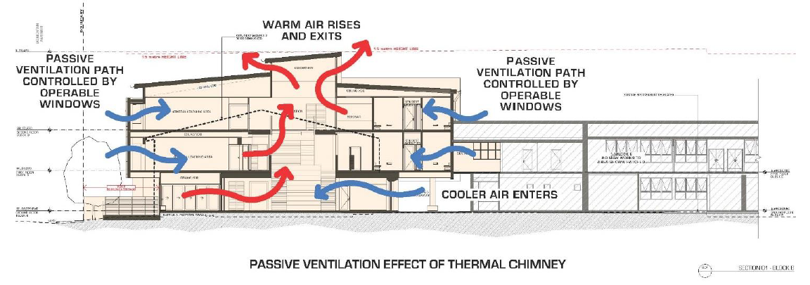
Assessment officers’ comment:

The applicant’s responses have merit and are supported. It’s noted the DEP acknowledged the proposed upper most levels increased setback from the south minimises overshadowing impacts on the open space south of the development.

SUSTAINABILITY

Key considerations:
- The student amenities on external walls should have natural light and ventilation.
- The method of window and door operation on each elevation should be accurate and indicated on all the drawings.
- Sun-shading and or weather protection should be provided to suit orientation.
- Consideration should be given to a solar hot water system.
- Photovoltaics should be included on the roof to mitigate energy
- Rainwater should be harvested, stored, treated and re-used, for WC’s and garden irrigation.

Applicants’ response:

Student amenities:

Response: The eastern wall of the student amenities bounds a proposed balcony and provides a source of natural light and ventilation. The balcony provides the following:
- An alternative to an enclosed dead-end passageway.
- Articulated the eastern elevation of the building.
- Access to the electrical cupboard and cleaner’s store
- A second access to the amenities. This second access provides escape opportunity in the event of bullying and opportunity for the provision of natural light and ventilation.

Method of door and window operation:

Response:

Figures below describes louvred windows as highlighted blue to indicate extent of opening windows.
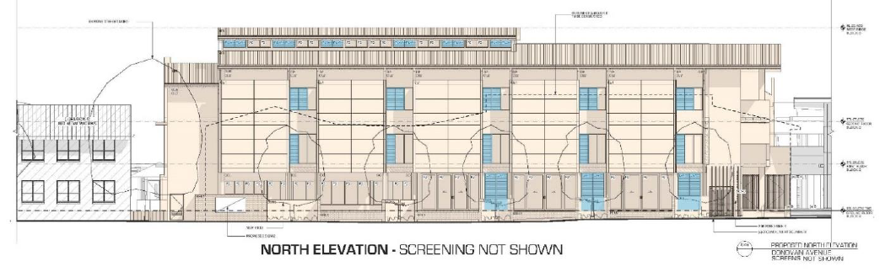
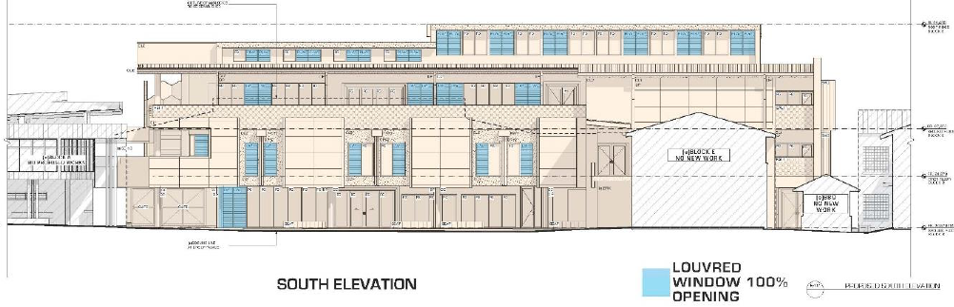
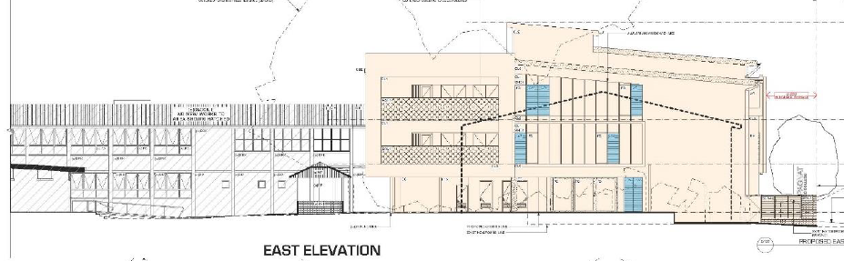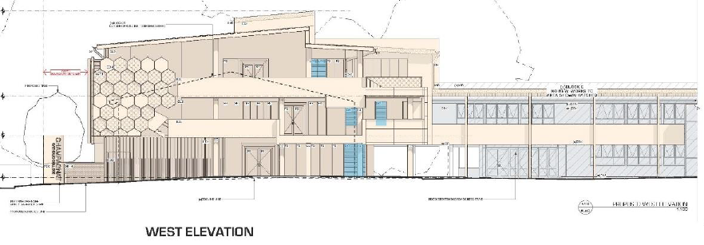

Figure below shows internal views of the northern elevation as seen from within a typical GLA space.

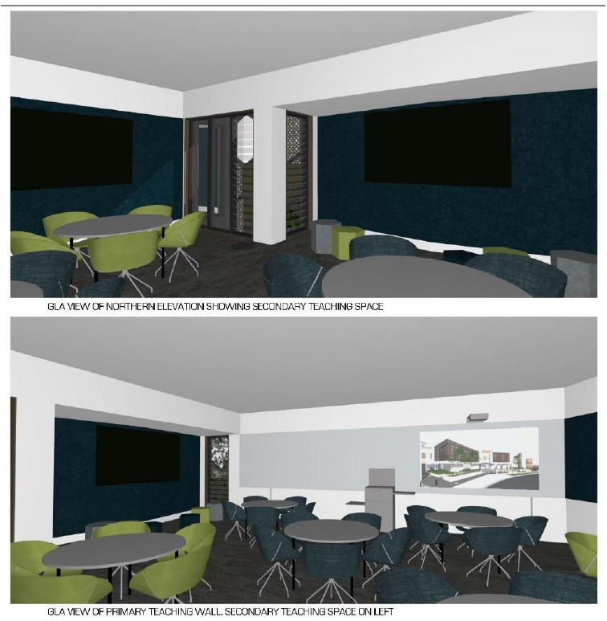
Sun shading and weather protection:
Response: Figure 11, 12, 13 describe sun shading and weather protection proposed. The building is adequately shaded, and weather protected.
Assessment officer comment: Figure 11 identifies that the first-floor level provides shading of the ground level. Figure 12 except of first floor level below shows perforated screens (green line) that run along the architectural blade walls provide sun protection:
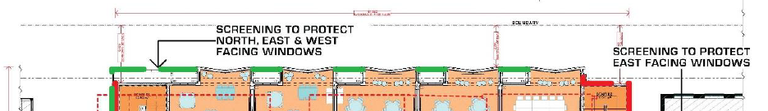

Solar hot water:
Response: The school has a solar hot water development program in place. A report describing the proposed solar program is appended to this document (refer Appendix 01). The solar hot water panels on the roof of the existing building which is to be demolished will be relocated to the roof of the new Administration building adjacent
Rainwater harvesting:
Response: The site is so constrained that there is nowhere to locate large rainwater harvesting tanks without diminishing valuable ground plane or floor area for teaching space.
Assessment officer comment:
The applicant has provided acceptable responses regarding the matters raised by the DEP in so far as the proposal includes good levels of sustainable energy saving measures and the existing site conditions contain their own restrictions on being able to provide additional water saving technologies.

LANDSCAPE
The Panel would like to see a building designed to accommodate the retention of all existing trees facing Donovan Avenue and less overshadowing of playground spaces.
Applicant response:
Landscape:
Response: Nine existing trees are proposed to be removed. Only one of these is a category B ranked tree (refer figure 14). The remainder are category C trees. The arborist report submitted with the DA identifies Category C trees as low retention value.
Five new trees are proposed. The new trees more than compensate for the removal of the single category B tree.
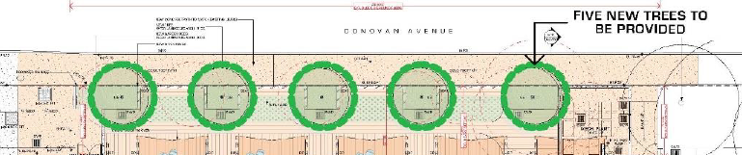
Assessment Officers comment:
The applicant’s response is noted and an assessment by Councils’ Landscape Officer has considered the proposal on its merits and raises no objections to the proposal subject to appropriate conditions being included should consent be granted.
AMENITY
The south facing canteen queueing area and covered way does not create great amenity and could be a congestion zone for pedestrians accessing block C. The method of servicing the canteen both for delivery of goods and removal of refuse and recycling should be shown.
The Panel did not understand the function of the balcony to the east of the student amenities on the second-floor plan.
The amenity of seminar room 7 on the ground floor is questioned due to the mechanical plant immediately adjacent to the north.
The reverberation time in the centre area of the new Block B with the tiered seating and internal voids should be assessed.
The location of the south western column appears uncomfortably close to the void enclosure wall should be reviewed. It may be that the enclosure wall can be reconfigured to allow comfortable movement around the column. The use of curved enclosure walls at this void also appears out of character with the rectangular and angular geometry of the plan.
Applicant response:
Amenity:
Response: Canteen queuing is located so as not to impact on the active space in the quadrangle. The majority of students utilize the main quadrangle. Locating the canteen queuing area adjacent this space is logical. Students will not be accessing Block C during lunch and recess which is when canteen queuing will occur.
Existing rubbish removal and canteen deliveries are unaltered by this proposal. Figure 15 describes location of current rubbish collection and canteen delivery.
Function of Balcony to east of student amenities.
Response: The balcony provides access to the electrical cupboard and cleaners store and a second access to the amenities. This second access provides escape opportunity in the event of bullying and opportunity for the provision of natural light and ventilation.
QOH can provide indicative information regarding management of Internal acoustics if required. (not required as it will be subject of documentation to be submitted in the CC).
Amenity of seminar room 7:
Response: This space is provided with fixed glazing and is mechanically ventilated and passively ventilated borrowing passively circulating air from the adjacent resource centre as is permitted under the National Construction Code.
The Panel raised concerns about management of reverberation throughout the building. The detailed development of acoustic treatments including mitigation of noise impact on seminar room 07 will be addressed as part of the detailed design development. Refer section 07 of acoustic impact report submitted as part of the Development Application.
Location of proposed column:
Response: The proposed column location and diameter is based upon a structural grid developed as part of the preliminary structural design. The clear distance between the column and the adjacent balustrade is 1000mm. This is wider than a standard doorway and provides adequate space to circulate around the column if required. QOH do not want to relocate the column, nor do we want to further enlarge the void and reduce floor area of the learning common.
Assessment officers’ comments:
The applicant’s responses are considered to have reasonably addressed the matters raised by the DEP and it is considered that reasonable amenity will be afforded for the future students, canteen queuing isn’t considered a significant concern for the reasons outlined by the applicant and the proposal does not seek to alter the waste management on site.
SAFETY
The safety issues regarding the thermal curtain on level two restricting access to the fire stair is questioned. The safety of stair B1 opening to the public space to the north of the site is also questioned.
Applicants’ response:
Safety:
Response: Stair B1 ground floor gates are required by the National Construction Code to open in the direction of egress. The western gate can be designed to swing 180 degrees and fold back against the adjacent screen. These gates do not open into a travel or circulation path.
The type of fire shutter proposed is commercially available and certified under Australian Standards. It is fitted with a controlled closing speed, motion sensor, strobe light and hold open button. The shutter is certified for the use proposed and will form part of a fire engineered solution for the project
Assessment officers’ comment:
The applicant’s responses to the safety issues raised are considered to appropriately address the DEP comments.
AESTHETICS
The stated principal, to have an open north elevation is not reflected in the plans which show a defensive enclosed elevation with inset windows. The elevations and planning should acknowledge orientation with open north facing windows and horizontal shading and smaller enclosed windows to the south.
The folded architectural plane elements on the north façade should be reimagined with scaling devices, potentially as solar shading, to provide a stronger relationship to the single-family residences to the north. These elements on the south façade do not relate as closely to the space planning of the adjacent rooms and might be reconsidered at this location. As noted above the building provides a 4th wall enclosure to the courtyard, not a building in the round, and as such may have very different façade treatments to suit orientation.
Applicants’ response:
Aesthetics:
Response: The ground floor of the building is open to the quadrangle to the south and courtyard to the north. The Panel’s description of the northern elevation as closed and defensive is not correct. The Northern elevation is:
• Articulated to reduce building mass and facilitate functions occurring in the adjacent spaces.
• Screened to provide shade protection to north facing windows while restricting overviewing of dwellings opposite.
The north elevation of each class room is provided with windows along 34% of its plan length. Figure 16 describes the plan extent of windows located on the northern elevation These windows are 2100mm high and 70% opening. Figure 17 describes a view of the extent of glazing to the north wall of a typical classroom on first and second floors.
The provision of a significant amount of glazing to the southern side of the building is a deliberate strategy to :
• Provide even south light to adjacent spaces, learning commons and voids.
• Provide a strong visual connection to the quadrangle space.
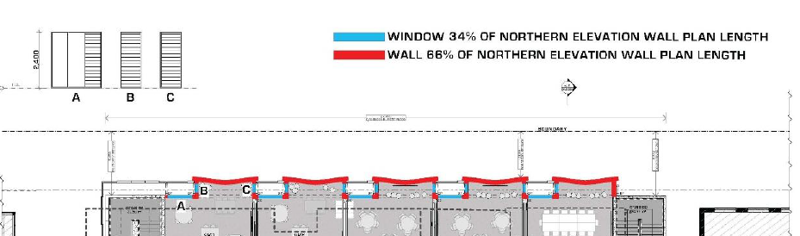
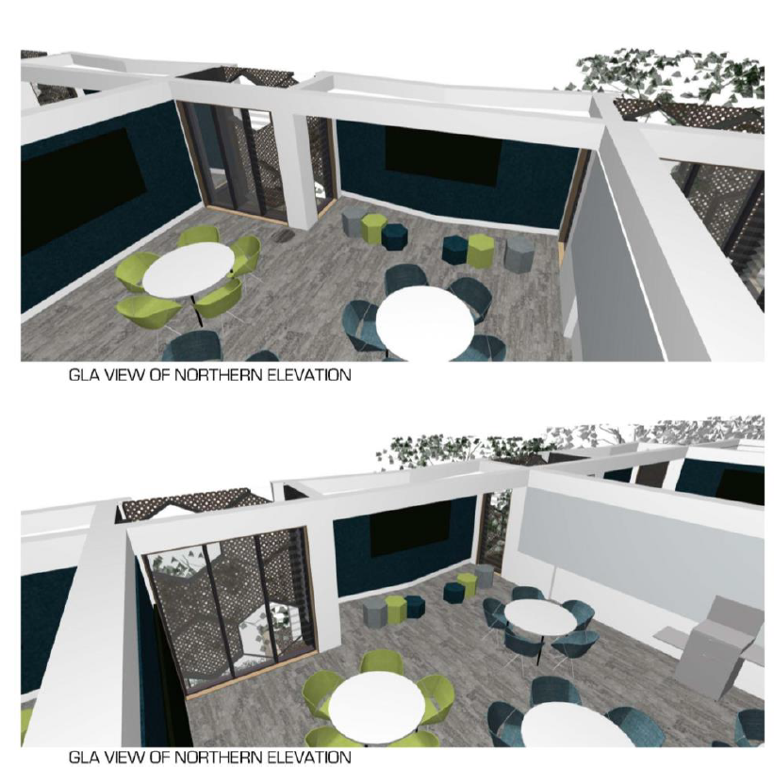

Folded Architectural plane elements:
Response: The proposal provides adequate scaling to the northern elevation. Transition in scale from the proposal to the 1 and 2 storey residential buildings located on Donovan Avenue opposite the site is achieved by the following:
• Solar shading proposed to the northern elevation in the form of articulated screens
• Articulated plan form of the northern wall
• Articulated building base, middle and roof elements
• Proposed fencing and new street trees
Further, the sections of solid wall proposed on the northern elevation are a functional response to the use of the adjacent internal spaces. Refer to figure 17. The design response has been to integrate the function requirement of the façade with an appropriately scaled and integrated series of façade elements.
The building has not been considered as 4 separate elevations because the intersection of elevations at North east, North west and south west corners can be observed from the ground plan. Consequently, the building has been designed as a 3-dimensional form containing integrated elevations. Figure 18 & 19 describes these elevations.
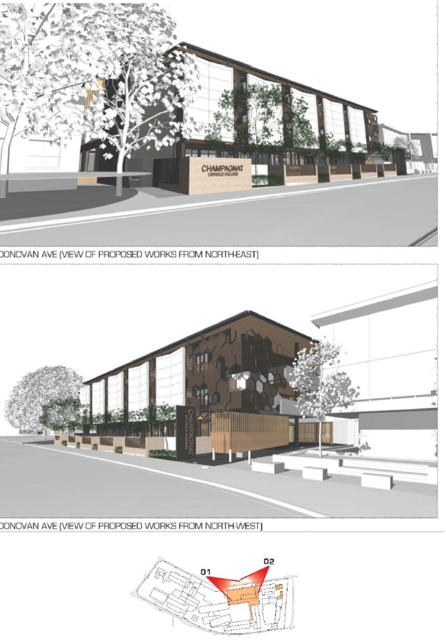

SUMMARY AND RECOMMENDATIONS
The Panel feel strongly that a master plan should be guiding the future development of this site, and questions the larger building being put on the north of the site and not the south. The acoustic and thermal amenity of the central public corridors and tiered learning spaces is of concern to the Panel. The general arrangement of general learning areas should be further explored to ensure future flexibility and adaptability. The day-to-day use of the fire stairs should be encouraged.
Applicants’ response:
Summary and Recommendations:
QOH will provide a concept masterplan as requested. Demolition of existing GLA blocks E+ F to re locate the proposed building is not viable.
The Panel’s concern regarding acoustic and thermal amenity of the learning commons is noted. Detailed design development will utilise the services of acoustic and mechanical engineers to assist with provision of a quality indoor environment. The internal stairs 2 have been designed to form part of the internal circulation path. Because it is a required exit it incorporates a fire screen as a fire engineered solution to facilitate this function.
The design of learning areas has been developed in close consultation with the Educators within the Sydney Catholic Schools Office and the school Principal. This design development process specifically targeted adaptability and future proofing of the proposed design. The applicant is satisfied the proposed design meets their educational objectives and has approved the proposed design for Development Application submission. The panel’s comments that advocate a different educational model (rather than planning principles) should be given little weight.

Design Excellence Panel – 2nd response to the additional material received by Council on 20 January 2021
PANEL COMMENTS
This proposal is for the demolition of a two-storey block B, and the replacement of block B with a two and three storey building, accommodating a resource centre, seminar rooms and canteen on the ground floor. On the first floor five general learning areas with tiered learning, common breakout spaces and seminar rooms, and on the second floor five general learning areas, a senior common area and amenities with a balcony.
The application also seeks to build demountable buildings to the east of the site for temporary accommodation during construction.
There was no master plan submitted with the proposal. There are a number of CDC developments which would be relevant to the assessment of this proposal and were not clearly shown in the documents. The registered architect for the project is QOH architects.
This is the second time the Panel has reviewed this proposal.
CONTEXT AND NEIGHBOURHOOD CONTEXT
Champagnat Catholic College sits to the north of the intersection of Bunnerong Road and Fitzgerald Avenue, to the south is Heffron Park, to the north individual dwelling houses, to the west our Lady of The Assumption church, Presbytery and brothers residence and to the east a storm water channel, Walsh Avenue and dwelling houses.
SCALE AND BUILT FORM
The Panel previously noted the importance of placing the current proposal into a masterplan context. The proponent noted in their response that a masterplan would be provided to Council for information.
The Panel notes the proponent’s responses to the functionality of the proposal and has no further commentary on:
- Triangular shaped seminar rooms
- Stair configuration
- Windows and doors functions
- Thermal chimney effects
SUSTAINABILITY
The Panel notes the proponent’s response to the sustainability aspects of the design has no further commentary on:
- The methods of window operation that are now shown on each elevation.
- The further information provided for on sun-shading and or weather protection on windows
- The replacement of the existing solar hot water system
- The lack of space for an above ground rainwater tank. This might, however, be placed below grade.
Ongoing considerations could still include:
- Photovoltaics should be included on the roof to mitigate energy
- The student amenities on external walls should have natural light and ventilation.
LANDSCAPE
The Panel would like to see a building designed to accommodate the retention of all existing trees facing Donovan Avenue but will defer to Council’s landscape architect for the appropriateness of proposed landscaping. Replacement trees should be a minimum size upon planting to ensure the appropriate character of the street remains in place.
AMENITY
The Panel notes the proponent’s responses to the amenity of the proposal and has no further commentary on:
- Operations considerations to reduce crowding at the canteen and Block C
- The function of the balcony to the east of the second floor student amenities
- The amenity of seminar room 7
- Sound attenuation in the centre area of the new Block B and internal voids
- The location of the south western column
SAFETY
The Panel notes the proponent’s responses to the safety assessment of the items below and has no further commentary on:
- The thermal curtain on level two
- The Stair B1 opening configuration
AESTHETICS
The panel maintains its commentary on the north façade and would like to see a revised design that presents as less defensive to the smaller scaled dwelling houses in the neighbourhood.
The folded architectural plane elements on the north façade should be reimagined with scaling devices, potentially as solar shading, to provide a stronger relationship to the street that could be enhanced by lowering the height of these screens closer to the built form opposite.
SUMMARY AND RECOMMENDATIONS
The Panel notes the proponent responses to most items and their specific programmatic drivers and has no further commentary. Some improvements to sustainability and landscape, however, should be encouraged by Council.
A reconsideration of the north façade in terms of its scale and relationship to the adjacent smaller scaled dwelling houses should be undertaken.
Assessment officers’ comments:
The applicant is considered to have reasonably responded to the DEP comments with particular regard to design quality principles in Schedule 4 of the SEPP Educational establishments.
Although the applicant raises a concern that the DEP commentary is provided under the SEPP 65 design quality principles and aren’t technically applicable, and not the SEPP Educational Establishment design quality principles, they have provided responses in good faith. It is also noted that between the 2 EPI’s they share common threads that are shared between the design quality principles applying to each form of development. They essential seek to ensure that the proposed development is suited to the future occupants or users of the development, the proposed built form fits in with the character of the area and presents an aesthetical development.
In these respects, the applicant is considered to have provided suitable responses to the matters raised by the panel.
With particular regard to the design quality principles in the SEPP Educational Establishments, it is considered they are largely satisfied. With particular regard to the context, built form and landscape, amenity and aesthetics the applicant, as indicated above, has provided relevant information that supports the notion that the proposal is both a positive response to the characteristics and context of the current and future use of the site as a school and its built form will be compatible with the nearby zone.
In particular, the applicant points out that the proposal is designed with a base, middle and top roof level which is a legitimate design response to the northern aspect and the functional requirements of the school inclusive of landscaping, modulation of the blade walls interspersed with perforated screens and suitably proportionate and configured glazing provides function and visual interest.
Whilst the proposed block B is proposed to be 15m in height which is 5.5m above the 9.5m maximum height of buildings standard applying to properties opposite in the nearby low-density zone, the greater than 15m width of Donovan Avenue provides visual relief and ensures that the proposed block B does not dominate but rather provides an appropriate built form for the school. The proposal also contains suitable stepped in building elements and a mix of materiality which will provide visual interest along Donovan Avenue.
It is recommended that the proposed colours and materials be submitted to Council for approval and shall be selected on the basis of using a compatible colour palette that seeks to softens and lends itself to showing off the modulating walls along the northern elevation.
External Referral

- Roads and Maritime Services/Transport for NSW

Pursuant to clause 57 of the SEPP Educational Establishments and Child Care Facilities) 2017, the application was externally referred to Transport for NSW (formally Roads and Maritime Services) for comment and/or recommendation. The RMS elected to not provide comments. It is noted that the no change in school population is proposed as part of this application. In addition, construction traffic management conditions have been included in the recommended conditions.

- Relevant Environmental Planning Instruments

The Development application has been assessed in accordance with the provisions of the following relevant planning documents:
- State Environmental Planning Policy (State and Regional Development) 2011
- State Environmental Planning Policy No. 55 – Remediation of Land
- State Environmental Planning Policy (Educational Establishments and Child Care Facilities) 2017
- Randwick Local Environmental Plan 2012.

- State Environmental Planning Policy (State and Regional Development) 2011

The proposal is in relation to an Educational Establishment with a capital investment value in excess of $5 million and identified as being “regionally significant development” pursuant to clause 5 of Schedule 7 of SEPP (State and Regional Development) 2011. In accordance with the requirements of the SEPP and Schedule 4A of the Environmental Planning and Assessment Act 1979, the determining authority for the submitted proposal classified as ‘regionally significant development’ is the Sydney Eastern Central Planning Panel (SECPP).

- State Environmental Planning Policy No. 55 – Remediation of Land

SEPP No. 55 aims to promote the remediation of contaminated land for the purposes of reducing the risk of harm to human health or any other aspect of the environment. Council’s Environmental Health Officers have reviewed the development application and it is considered that subject to the recommendations of the submitted reports and further detailed site investigation, the site can be made suitable for its intended purpose. Relevant conditions of consent shall be imposed should the application be approved.

- State Environmental Planning Policy (Educational Establishments and Child Care Facilities) 2017 (SEPP Educational Establishments)

SEPP Educational Establishments aims to facilitate the effective delivery of educational establishments and early education and care facilities by establishing reliable and consistent assessment criteria and design considerations for educational establishments. Pursuant to clause 35 of SEPP (Educational Establishments), the proposed development is located within a prescribed zone, being a SP2 zone, and therefore development for the purpose of a school is permitted with consent. In accordance with subclause (6) of clause 35 of the SEPP, before determining the development application, the consent authority must take into consideration:

(a) the design quality of the development when evaluated in accordance with the design quality principles set out in Schedule 4, and

(b) whether the development enables the use of school facilities (including recreational facilities) to be shared with the community.

Schedule 4 provides seven (7) design principals, which are addressed below:

Principle 1—context, built form and landscape

- Schools should be designed to respond to and enhance the positive qualities of their setting, landscape and heritage, including Aboriginal cultural heritage. The design and spatial organisation of buildings and the spaces between them should be informed by site conditions such as topography, orientation and climate.
- Landscape should be integrated into the design of school developments to enhance on-site amenity, contribute to the streetscape and mitigate negative impacts on neighbouring sites.
- School buildings and their grounds on land that is identified in or under a local environmental plan as a scenic protection area should be designed to recognise and protect the special visual qualities and natural environment of the area and located and designed to minimise the development’s visual impact on those qualities and that natural environment.

The site is highly constraint by the existing buildings on the site and it is apparent from the history of applications, it is seeking to upgrade/refurbish and replace existing buildings on site whilst maintaining operation, limiting its ability to reconfigure the existing layout to its optimum. Notwithstanding, the proposal is considered to fit in comfortably within the context of the site and surrounding area and provides for suitable levels of landscaping across the Donavan Avenue frontage. In particular, the proposed ground level is setback further below the levels above and with an open design providing an inclusive entry level point from along Donovan Avenue.

The proposed built form is also considered to be an appropriate response to the existing north south orientation of Block B providing both suitable internal amenity for students as well as ensuring that the development’s overall built form offers visual interest through a mix of materials, modulated walls at first floor level, perforated screens and landscaping.

Principle 2—sustainable, efficient and durable

- Good design combines positive environmental, social and economic outcomes. Schools and school buildings should be designed to minimise the consumption of energy, water and natural resources and reduce waste and encourage recycling.
- Schools should be designed to be durable, resilient and adaptable, enabling them to evolve over time to meet future requirements.

The proposed design seeks to maximise natural light incorporating windows on all building facades whilst also utilising shading devices to minimise solar heat gain into the building and provide a balance between natural light and heat gain particularly along the northern elevation. The stepped out northern elevation inclusive of side facing windows allows for light as well as an internal layout that provides a focal point within each class room and also maximises the size of each classroom. The development also proposes the use of Photovoltaic panels on the roof for power generation. The existing drainage on the site shall be the subject of development engineers’ requirements. Conditions are also included requiring the incorporation of energy efficient fixtures, fittings and lighting to further minimise energy consumption.

Principle 3—accessible and inclusive

- School buildings and their grounds should provide good wayfinding and be welcoming, accessible and inclusive to people with differing needs and capabilities.

Note—
Wayfinding refers to information systems that guide people through a physical environment and enhance their understanding and experience of the space.
Schools should actively seek opportunities for their facilities to be shared with the community and cater for activities outside of school hours.

The proposed development involves a new building and the application states that the proposal is to include way finding signage on site to ensure it remains accessible and inclusive.

The amended plans seek to ensure compliance with the relevant accessibility provisions and that equitable access to all persons will be obtained to the new building.

The proposed development also seeks to improve the connectivity with the nearby buildings on site providing a covered walkway to the southern Block.

Principle 4—health and safety

- Good school development optimises health, safety and security within its boundaries and the surrounding public domain, and balances this with the need to create a welcoming and accessible environment.

The proposed development seeks to provide a flexible arrangement to learning spaces including breakout spaces, flexible arrangement to spaces and high floor to floor heights of 3.7m which is considered to improve the health and well-being of students and staff.

The proposed ground level is open in design with 1.7m to 1.75m high perforated fencing interspersed with narrow brick work piers along Donovan Avenue ensuring both causal surveillance in between the public domain and the school. The proposed development is considered to provide a reasonable balance between the safety and security of the school, and a welcoming and accessible environment.

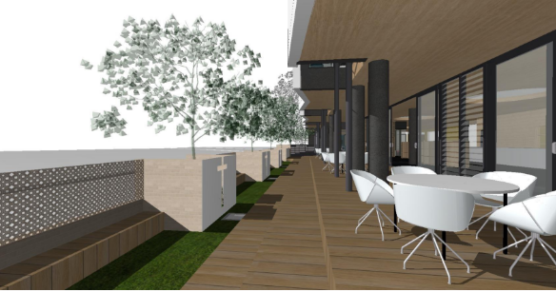

Principle 5—amenity

- Schools should provide pleasant and engaging spaces that are accessible for a wide range of educational, informal and community activities, while also considering the amenity of adjacent development and the local neighbourhood.
- Schools located near busy roads or near rail corridors should incorporate appropriate noise mitigation measures to ensure a high level of amenity for occupants.
- Schools should include appropriate, efficient, stage and age appropriate indoor and outdoor learning and play spaces, access to sunlight, natural ventilation, outlook, visual and acoustic privacy, storage and service areas.

The proposed development seeks to improve the amenity of the existing school by providing additional educational and break out resource spaces that are able to be flexibly configured depending on the number of students and nature of learning.

The main informal breakout areas have been orientated towards the interior of the site, adjacent to the existing outdoor areas, with the classrooms focused on the northern façade, to minimise impacts upon surrounding residential properties. The proposed design provides windows on all elevations to provide both for solar access, natural ventilation as well as provide appropriate shading for the classroom environment.

The amenity of students and staff is considered to have been satisfied by the proposed design.

Principle 6—whole of life, flexible and adaptive

- School design should consider future needs and take a whole-of-life-cycle approach underpinned by site wide strategic and spatial planning. Good design for schools should deliver high environmental performance, ease of adaptation and maximise multi-use facilities.

A concept plan or DCP is not required for schools. The applicant has indicated a willingness to submit a concept plan or DCP for the site however as yet one hasn’t been submitted. Notwithstanding it is clear that the proposed replacement of Block B is seeking a whole-of-life-cycle approach which is considered to be underpinned by the flexibility in the layout design of the development and focus towards break out spaces whilst also providing traditional class room layouts.

Principle 7—aesthetics

- School buildings and their landscape setting should be aesthetically pleasing by achieving a built form that has good proportions and a balanced composition of elements. Schools should respond to positive elements from the site and surrounding neighbourhood and have a positive impact on the quality and character of a neighbourhood.
- The built form should respond to the existing or desired future context, particularly, positive elements from the site and surrounding neighbourhood, and have a positive impact on the quality and sense of identity of the neighbourhood.

Due to the zoning of the site, being SP2, and the type of development, being an Educational Establishment, there are no specific built form controls contained within RLEP 2012 or RDCP 2013 applicable to the proposed development.

The proposed development was reviewed by Council’s Design Excellence Panel, who raised concerns regarding the ‘defensive enclosed elevation with inset windows. The elevations and planning should acknowledge orientation with open north facing windows and horizontal shading and smaller enclosed windows to the south.

The folded architectural plane elements on the north façade should be reimagined with scaling devices, potentially as solar shading, to provide a stronger relationship to the single-family residences to the north.’

The applicant provided additional information that showed that the amount of glazing across the front northern elevation amounted to around 34% of the surface area of the northern elevation. Whilst the inset windows don’t face north directly, they will be partially viewable through the perforated screens moving along Donovan Avenue. In relation to the folded architectural plane elements, the applicant contends that these are a functional response to the use of the adjacent internal spaces which is noted by the assessment officer as being another key design quality principle under the SEPP. The applicant further contends that the relationship with the adjoining nearby low-density zone is achieved through appropriately scaled and integrated series of façade elements which are noted by the assessment officer as including a mix of materiality and stepped in building elements that provide a 3D dimensional form within the streetscape. It is further noted, that the greater than 15m width of Donovan Avenue provides an element of visual relief when viewed from the opposite side of Donovan Avenue. At human scale the proposal provides relief through an open style ground level and suitably sized landscaping along the front of the building.

In view of the above, the proposed development is considered to be consistent with the design quality principles stipulated for schools. Clause 35 of the SEPP also requires Council to consider whether the development enables the use of the school facilities to be shared with the community. The proposed development involves a new building which contains open layout at ground level which is conducive to be used for multi-functional uses and therefore use by the community.

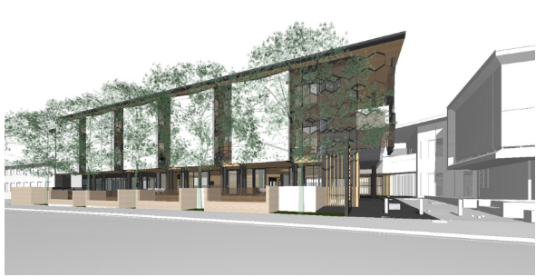
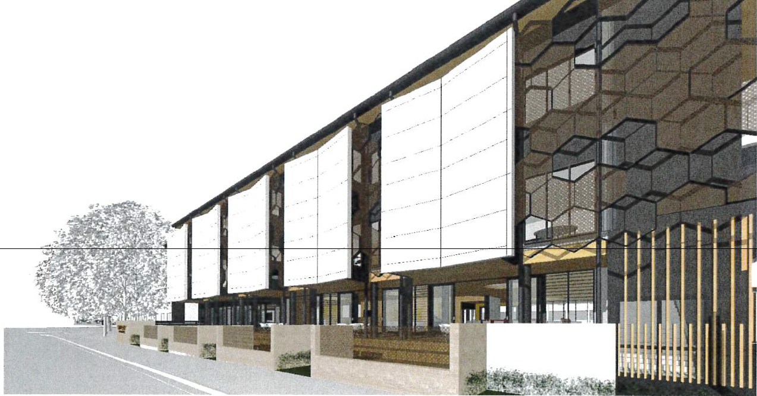

- Clause 38 Existing schools - exempt development

Demountable buildings are permitted as exempt development under cl 38 (1) of the SEPP Educational establishments if criteria is met. The proposal does not meet the criteria as it seeks to use the demountable for a purpose other than classrooms (being for canteen and toilets) and it is sited closer than 5m from the site boundary along Walsh Avenue (being 7.975m from the Donovan Avenue boundary and compliant with the minimum CDC setback control).

An assessment is required against the relevant objectives in the SEPP Educational establishments and relevant objectives in the RLEP and RDCP. Given the demountable buildings are limited to single storey in height and of a temporary nature, it is not considered that they will result in any long-term adverse impacts on the amenity of the neighbouring properties or the character of the area. It is also noted that the applicant indicates that following removal of the demountable buildings the ground will be made good and planting in its place ensuring the current tree lined frontage along Walsh Avenue is maintained. A suitable condition is included.

- Randwick Local Environmental Plan 2012.

Randwick Local Environmental Plan 2012 (RLEP)

The subject site is zoned SP2 – Educational Establishment pursuant to the Land Use Table and Land Zoning Map within RLEP 2012. The following sections and clauses in the RLEP apply to the proposal: -

Part 2 – Land Use Zoning

The objectives of the SP2 zone are as follows:

- To provide for infrastructure and related uses.
- To prevent development that is not compatible with or that may detract from the provision of infrastructure.
- To facilitate development that will not adversely affect the amenity of nearby and adjoining development.
- To protect and provide for land used for community purposes.

The proposed development is for demolition of existing Building B and construction of new Building B for the existing school known as Champagnat College, defined as an Educational Establishment pursuant to the Dictionary of RLEP 2012 (and standard instrument).

The proposed development is an educational establishment and constitutes critical infrastructure for the purposes of flooding during in 1 in 500-year storm event.

The proposed development is not anticipated as resulting in any unreasonable adverse impacts upon the residential amenity of surrounding and adjoining properties, namely those located to the north or west on the opposite sides of Donovan Avenue and Walsh Avenue respectively.

Overall, the proposed development is considered to satisfy the relevant objectives of the SP2 zone subject to conditions.

Clause 4.3 – Height of buildings

The objectives of Clause 4.3 are as follows:

- to ensure that the size and scale of development is compatible with the desired future character of the locality,
- to ensure that development is compatible with the scale and character of contributory buildings in a conservation area or near a heritage item,
- to ensure that development does not adversely impact on the amenity of adjoining and neighbouring land in terms of visual bulk, loss of privacy, overshadowing and views.

Clause 4.4 – Floor Space Ratio

The objectives of Clause 4.4 are as follows:

- to ensure that the size and scale of development is compatible with the desired future character of the locality,
- to ensure that buildings are well articulated and respond to environmental and energy needs,
- to ensure that development is compatible with the scale and character of contributory buildings in a conservation area or near a heritage item,
- to ensure that development does not adversely impact on the amenity of adjoining and neighbouring land in terms of visual bulk, loss of privacy, overshadowing and views.

There is no maximum height specified for the subject site on the Height of Buildings Map. As such the proposed development is assessed on merit against the objectives of cl 4.3.

An appropriate methodology in carrying out this merit assessment is provided for in the Land and Environment Court planning principle that seeks to ascertain the compatibility of a proposal with the surrounding development. The key case cited in this character test is Project Venture Developments Pty Ltd v Pittwater Council [2005] NSWLEC 191 at 22-31. An outline of the test includes ascertaining the:

- Identity of the local context,
- Compatibility of built form that is:

- Is the appearance of the proposal in harmony with surrounding development and the character of the area?

- What are the physical impacts of the proposal on the amenity of neighbouring properties having regard to visual amenity, privacy, overshadowing and views.

And

- Compatibility of use.

- Identify the local area (Context)

The extent of land use surrounding the subject site are predominately low density residential within sites zoned R2 low density residential to the north east and west with the subject site containing the school both secondary and primary and the parish contained within its own block of land facing four separated street frontages. Properties to the south on the opposite side of Bunnerong Road are zoned RE1 recreational used for public recreation and properties located within the adjoining local government area of Bayside Council also zoned low density residential.

The low-density zone to the north, east and west are permitted a maximum building height of 9.5m and a density that is scaled against the land size with larger land over 600sqm restricted to a density of 0.6:1 and smaller land sized between 300sqm and 450sqm restricted to a density of 0.75:1 maximum.

The subject site bounded by four roads has a site area of around 1.584ha. No maximum height applies to development in the Public recreation zone.

- Compatibility of built form:

The consent authority is required to take into consideration whether the design of the development is compatible with the character of the local area.

- Is the appearance of the proposal in harmony with surrounding development and the character of the area?

The proposal as amended is consistent with the existing and desired streetscape character, presenting as a three-storey development. Whilst it has a 15m height which significantly exceeds the 9.5m maximum height applying to the residential zone to the north, east and west it is considered suitable for the following reasons:

The subject site has contained school buildings on site for a considerable period and the massing and length of buildings on site contain buildings that already exceed the maximum height. Moreover, the CDC provisions allow for school development to attain a maximum height of 22m, or four storeys and the proposed development seeks a three-storey built form which is 7m below the CDC maximum.

The proposal does however seek a shallower setback of between 3.8m and 5.5m with a 6m minimum setback applies under the CDC. This shortfall in the setback below the CDC provisions is considered to be reconciled and will not dominate the nearby low-density zone by the fact that the shortfall is minor along the majority of the building length along Donovan Avenue, the proposed building is 7m lower than that which would be afforded by the CDC provisions and the 15m wide carriageway along Donovan Avenue provides ample separation from the low-density zones opposite. In addition, the proposed Block B building is in line with the existing Block A maintaining a consistent front setback along this frontage.

The next consideration is are the physical impacts of the proposal on surrounding development acceptable?.

The physical impacts of the proposal on the amenity of neighbouring properties having regard to key aspects of visual amenity, privacy, overshadowing and views are assessed as follows:

Visual amenity

In terms of visual amenity, the proposed development will essentially read as a three-storey development when viewed from the street and surrounding properties. The proposal fits in comfortably within the large site area which is considered able to sustain larger built forms and the areas that are sited closest to the front boundary along Donovan Avenue contain stepped folded architectural walls that provide visual interest when viewed along Donovan Avenue.

The proposed setbacks will not adversely impact on the fair and equitable access to natural light and fresh air of nearby residential properties.

Overshadowing

The proposal is sited to the south of the residential zones and does not result in unreasonable adverse overshadowing.

Privacy

The proposed development is privately designed in regard to providing for reasonable amenity to the neighbouring properties opposite along Donovan Avenue due to the separation provided from these properties and use of appropriate design to mitigate against visual outlook.

Views

The proposed Block B building is not considered to result in any loss of high value views from neighbouring properties.

Overall, with regards to visual amenity, the proposal is considered to provide for a suitable scale to the street and contributes to its character, it does not cause unreasonable impacts upon the neighbouring dwellings in terms of overshadowing, view loss, privacy and visual amenity.

- Compatibility of use:

The proposed development constitutes an on-going permissible development and its continued use should not be disputed. The proposed uses within the building provide energy efficiency through the use of photovoltaic panels on the roof and its use as a school remains compatible with the surrounding uses providing for future educational development and community uses.

Clause 6.11 – Design Excellence

Clause 6.11 of RLEP 2012 aims to ensure that a high standard of architectural and urban design is achieved for certain types of development which involves the following:

“development involving the construction of a new building or external alterations to an existing building—

- on a site that has an area of 10,000 square metres or greater, or
- on land for which a development control plan is required to be prepared under clause 6.12, or
- that is, or will be, at least 15 metres in height”

The subject site has an area of approximately 1.58ha however it is not subject to subclause b) which applies clause 6.12 of RLEP 2012 and requires the preparation of a site-specific development control plan as the provisions in the SEPP Educational establishments specifically exclude the application of this clause to schools. As such, the provisions of clause 6.11 are applicable to the proposed development.

In considering whether the proposed development exhibits design excellence, the application was referred to Randwick Design Excellence Panel. A detailed response to the proposed development is provided in section 6 of this report inclusive of the applicant’s response to the matters raised and the assessment officers’ comments.

Subject to the inclusion of a condition requiring colours and materials, the proposed development is considered to achieve an appropriate standard of architectural design. Furthermore, the proposed works shall replace an existing dated building and enhance the streetscape presentation to Donovan Avenue.

In view of the above, it is considered that the consent authority can be satisfied that the proposed development exhibits design excellence in accordance with the provisions of clause 6.11.

  - Policy Controls

a. Development Control Plan Randwick Comprehensive Development Control Plan 2013 (RDCP)

Section B6 – Recycling and Waste Management

An assessment of the waste management of the proposed development has been undertaken by Council’s Development Engineering and relevant conditions of consent shall be imposed accordingly. It is considered that the waste management of the development can be appropriately managed through the proposed conditions.

Section B7 – Transport, Traffic, Parking and Access

The proposal does not seek to increase the number of students or staff in the school and therefore there are no specific vehicle parking rates applicable to the proposed development. Certain conditions are included requiring submission and approval of a Construction Traffic Management Plan during the course of demolition and construction of the proposed Block B building and demountable buildings.

Section F2 Outdoor Advertising and Signage

Clause/Control | Proposed | Complies Y/N
2 General Design and siting
i) Signage should recognise the legitimate needs for directional advice, business identification and promotion. ii) Signage must complement and be compatible with the development on which it is situated and with adjoining development.  iii) Signage should not obscure architecturally decorative details or features of buildings or dominate building facades. It should be placed on the undecorated wall surfaces or designed sign panels provided.  iv) Entire building facades and /or walls must not be painted or covered with cladding or other material to act as a large billboard type.  vi) Signage shall be displayed in English but may include a translation in another language  ix) Signage must not be flashing or animated. Note: Flashing or animated signs include mechanical moving signs, moving LED signs, video/television screens, projected laser advertising and other flashing, intermittently illuminated or sequenced lighting signs. | The proposal seeks consent to provide for way finding within the site, and building identification.  Signage will be located in key strategic locations and will not obscure any architectural decorative details within the approved or proposed developments.  Content is conditioned to contain English.  No signs are flashing. | Acceptable
3 Signage based on Land Use Zones – Special Purpose
i) Signage must not be flashing or animated.  ii) Signage must be designed and located so that it forms an integral part of the building or land upon which it is situated.  iii) The number of signs should be kept to a minimum. Where possible signs should be grouped together. Avoid a proliferation of advertising material. | No signs are flashing.  The signage is integral to the site.  Number of signage is necessary for the effective way finding throughout the site, and identification of buildings and specific shops. | Acceptable

  - Council Policies
Randwick City Council Development Contributions Plan

A suitable condition is included requiring the payment of a section 7.12 contribution in accordance with the requirements of Council’s plan.

- Environmental Assessment

The site has been inspected and the application has been assessed having regard to Section 4.15 of the Environmental Planning and Assessment Act, 1979, as amended.

Section 4.15 ‘Matters for Consideration’ | Comments
Section 4.15(1)(a)(i) – Provisions of any environmental planning instrument | Refer to the “Environmental Planning Instruments” section of this report for details.
Section 4.15(1)(a)(ii) – Provisions of any draft environmental planning instrument | N/A
Section 4.15(1)(a)(iii) – Provisions of any development control plan | Refer to “Policy Control” section of this report above for details.
Section 4.15(1)(a)(iiia) – Provisions of any Planning Agreement or draft Planning Agreement | N/A
Section 4.15(1)(a)(iv) – Provisions of the regulations | The relevant clauses of the Environmental Planning and Assessment Regulation 2000 will be addressed by recommended conditions.
Section 4.15(1)(b) – The likely impacts of the development, including environmental impacts on the natural and built environment and social and economic impacts in the locality
Section 4.15(1)(c) – The suitability of the site for the development | The subject development is for alterations and additions to the existing school. The site is zoned for the purpose of an Educational Establishment and as such the site is considered to be a suitable location for the proposed development.
Section 4.15(1)(d) – Any submissions made in accordance with the EP&A Act or EP&A Regulation | No submissions have been received.
Section 4.15(1)(e) – The public interest | The proposal will not result in any unreasonable or unacceptable environmental, social or economic impact. Therefore, it is considered that the proposal is in the public interest.

- Conclusion

The proposal meets the objectives of the key development standards and policy controls relating to this site, the proposed development and surrounding area.

The proposed development is permissible for the site zoned SP2 Educational Establishment. The proposal satisfies the relevant objectives contained within RLEP 2012 and the relevant requirements of RDCP 2013 and is consistent with the design quality principles as required by SEPP Educational Establishments.

Subject to the recommendations within the report, the development will not result in any unreasonable impacts on surrounding properties or the public domain.

The application is therefore recommended for approval subject to conditions.

- Recommendation

THAT the Sydney Eastern City Planning Panel, as the consent authority, grants development consent under Sections 4.16 and 4.17 of the Environmental Planning and Assessment Act 1979, as amended, to Development Application No. DA/249/2020 for demolition of existing Block B, construction and replacement of Block B (three storeys), temporary demountable buildings, continued use as an educational establishment, building identification signage, tree removal, landscaping and associated works at No. 25-45 Donovan Avenue, MAROUBRA, NSW 2035, subject to the following conditions:

GENERAL CONDITIONS
The development must be carried out in accordance with the following conditions of consent.
These conditions have been applied to satisfy the relevant requirements of the Environmental Planning & Assessment Act 1979, Environmental Planning & Assessment Regulation 2000 and to provide reasonable levels of environmental amenity.

Approved Plans & Supporting Documentation
- The development must be implemented substantially in accordance with the plans and supporting documentation listed below and endorsed with Council’s approved stamp, except where amended by Council in red and/or by other conditions of this consent:

Plan | Drawn by | Dated
DA/1100 Issue 02 (Proposed Site Plan) | QOH Architects | 27/04/20
DA1101 Issue 02 (Site Analysis Plan) | QOH Architects | 27/04/20
DA1500 Issue 03 (Site elevations and signage details) | QOH Architects | 23/12/20
DA1550 Issue 03 (Site sections) | QOH Architects | 23/12/20
DA2200 Issue 02 (Ground floor Demolition Plan Block B) | QOH Architects | 27/04/20
DA2201 Issue 01 (Ground Floor Demolition Plan Block B) | QOH Architects | 27/04/20
DA2202 Issue 02 (First Floor Demolition Plan Block B) | QOH Architects | 27/04/20
DA2220 Issue 04 (Ground floor plan) | QOH Architects | 23/12/20
DA2221 Issue 04 (First floor plan) | QOH Architects | 23/12/20
DA2222 Issue 02 (First floor plan) | QOH Architects | 23/12/20
DA2223 Issue 04 (Second floor plan) | QOH Architects | 23/12/20
DA2300 Issue 04 (North & South elevation) | QOH Architects | 23/12/20
DA2301 Issue 04 (East & West elevation) | QOH Architects | 23/12/20
DA2302 Issue 01 (North elevation screens not shown) | QOH Architects | 23/12/20
DA2350 Issue 05 (Section 01) | QOH Architects | 23/12/20
DA2800 Issue B to DA2803 (Landscape Plan 1, 2 & 3 and Typical details) | O’Hanlon Design Pty Ltd | 23.04.20
DA2910 Issue 03 (Portable Building Floor Plan) | QOH Architects | 28/04/20

Amendment of Plans & Documentation
- The approved plans and documents must be amended in accordance with the following requirements:

REQUIREMENTS BEFORE A CONSTRUCTION CERTIFICATE CAN BE ISSUED

The following conditions of consent must be complied with before a ‘Construction Certificate’ is issued by either an Accredited Certifier or Randwick City Council. All necessary information to demonstrate compliance with the following conditions of consent must be included in the documentation for the construction certificate.

These conditions have been applied to satisfy the relevant requirements of the Environmental Planning & Assessment Act 1979, Environmental Planning & Assessment Regulation 2000, Council’s development consent conditions and to achieve reasonable levels of environmental amenity.

Consent Requirements
- The requirements and amendments detailed in the ‘General Conditions’ must be complied with and be included in the construction certificate plans and associated documentation.

Section 7.12 Development Contributions
- In accordance with Council’s Development Contributions Plan effective from 21 April 2015, based on the development cost of $17,715,511.00 the following applicable monetary levy must be paid to Council: of $177,155.11.

The levy must be paid in cash, bank cheque or by credit card prior to a construction certificate being issued for the proposed development. The development is subject to an index to reflect quarterly variations in the Consumer Price Index (CPI) from the date of Council’s determination to the date of payment. Please contact Council on telephone 9399 0999 or 1300 722 542 for the indexed contribution amount prior to payment.
To calculate the indexed levy, the following formula must be used:
IDC = ODC x CP2/CP1

Where:
IDC = the indexed development cost
ODC = the original development cost determined by the Council
CP2 = the Consumer Price Index, All Groups, Sydney, as published by the ABS in respect of the quarter ending immediately prior to the date of payment
CP1 = the Consumer Price Index, All Groups, Sydney as published by the ABS in respect of the quarter ending immediately prior to the date of imposition of the condition requiring payment of the levy.

Council’s Development Contribution Plans may be inspected at the Customer Service Centre, Administrative Centre, 30 Frances Street, Randwick or at www.randwick.nsw.gov.au.

Compliance Fee
- A development compliance and enforcement fee of $5,000.00 shall be paid to Council in accordance with Council’s adopted Fees & Charges Pricing Policy, prior to the issue of a Construction Certificate for development.

Long Service Levy Payments
- The required Long Service Levy payment, under the Building and Construction Industry Long Service Payments Act 1986, must be forwarded to the Long Service Levy Corporation or the Council, in accordance with Section 6.8 of the Environmental Planning & Assessment Act 1979.

At the time of this development consent, Long Service Levy payment is applicable on building work having a value of $25,000 or more, at the rate of 0.35% of the cost of the works.

Sydney Water Requirements
- All building, plumbing and drainage work must be carried out in accordance with the requirements of the Sydney Water Corporation.

The approved plans must be submitted to the Sydney Water Tap in™ online service, to determine whether the development will affect Sydney Water’s waste water and water mains, stormwater drains and/or easements, and if any further requirements need to be met.

The Sydney Water Tap in™ online service replaces the Quick Check Agents as of 30 November 2015

The Tap in™ service provides 24/7 access to a range of services, including:

- Building plan approvals
- Connection and disconnection approvals
- Diagrams
- Trade waste approvals
- Pressure information
- Water meter installations
- Pressure boosting and pump approvals
- Change to an existing service or asset, e.g. relocating or moving an asset.

Sydney Water’s Tap in™ in online service is available at:
https://www.sydneywater.com.au/SW/plumbing-building-developing/building/sydney-water-tap-in/index.htm

The Principal Certifier must ensure that the developer/owner has submitted the approved plans to Sydney Water Tap in online service.

Street Tree Protection
- In order to ensure retention of the row of three Callistemon viminalis (Bottlebrush) that are located on Council’s Donovan Avenue nature strip, directly opposite Wackett Street in good health, the following measures are to be undertaken:

a. All documentation submitted for the Construction Certificate application must show their retention, with the position and diameter of both their trunks and canopies to be clearly and accurately shown in relation to the works.

- Each tree must be physically protected by installing evenly spaced star pickets at a setback of 1 metre to their east and west (measured off the outside edge of their trunks at ground level), matching up with the back of the kerb to their north, and against the footpath to their south, to which,h safety tape/para-webbing/shade cloth or similar shall be permanently attached so as to completely enclose each tree for the duration of works.

- This fencing shall be installed prior to the commencement of demolition and construction works and shall remain in place until all works are completed, to which, signage containing the following words shall be clearly displayed and permanently attached: “TREE PROTECTION ZONE (TPZ), DO NOT REMOVE/ENTER".

- If additional trunk or branch protection is required, this can be provided by way of wrapping layers of geo-textile, underfelt, carpet, hessian or similar around affected areas, to which, lengths of evenly spaced hardwood timbers shall be placed around their circumference, and are then to be secured by 8 gauge wires or steel strapping at 300mm spacing. NO nailing to the trunk.

- The applicant is not authorised to perform any other works to these public trees, and must contact Council’s Landscape Development Officer on 9093-6613 should clearnce pruning or similar be necessary. If approval is given, it can only be performed by Council, wholly at the applicants cost, with payment to be received prior to pruning, and prior to any Occupation Certificate.

- Within the TPZ’s, there is to be no storage of materials, machinery or site office/sheds, nor is cement to be mixed or chemicals spilt/disposed of and no stockpiling of soil or rubble, with all Site Management Plans needing to acknowledge these requirements.

- The Principal Certifier must ensure compliance with all of these requirements, both on the plans as well as on-site during the course of construction, and prior to any Occupation Certificate.

- A refundable deposit in the form of cash, credit card or cheque for an amount of $1,500.00 must be paid at the Cashier on the Ground Floor of the Administrative Centre, prior to a Construction Certificate being issued for the development, in order to ensure compliance with the conditions listed in this consent, and ultimately, preservation of the trees.

The refundable deposit will be eligible for refund following the issue of an Occupation Certificate, subject to completion and submission of Council’s ‘Security Deposit Refund Application Form’, and pending a satisfactory inspection by Council’s Landscape Development Officer (9093-6613).

Any contravention of Council's conditions relating to the trees at any time during the course of the works, or prior to any Occupation Certificate, may result in Council claiming all or part of the lodged security in order to perform any rectification works necessary, as per the requirements of 80A (6) of the Environmental Planning and Assessment Act 1979.

Tree Protection Measures
- In order to also ensure retention of the following nine (9) trees, T51-53, 55-58, 61 & 72, as identified in the Arboricultural Impact Assessment by ArborSafe, dated 21/01/20 (‘the Arborists Report’), which are all located within the subject site in good health, the following measures are to be undertaken:

- All documentation submitted for the Construction Certificate application must show their retention, with the position and diameter of both their trunks, canopies, SRZ’s, TPZ’s & tree identification numbers to be clearly and accurately shown on all plans in relation to the works.

- Prior to the commencement of any site works, the Principal Certifier must ensure that an AQF Level 5 Arborist (who is eligible for membership with a nationally recognized organization/association) has been engaged as ‘the Project Arborist’ for the duration of works, and will be responsible for both implementing and monitoring these conditions of development consent, as well as Section 8, Recommendations of the Arborist Report, including incorporating the requirements of Section 8.10-8.11 into the scope of works, with all site staff to comply with any instructions issued.

- The Project Arborist must be present on-site at the relevant stages of works, and must keep a log of the dates of attendance and the works performed, which is to be presented as a Final Compliance Report, for the approval of the Principal Certifier, prior to any Occupation Certificate.

- All Construction Certificate plans must show that the footprint, extent of works and deep soil/landscaped areas will be consistent with the architectural plans by QOH Architects, dwg’s DA1000-2970, rev 03, dated 01/05/20.

- These trees are to be physically protected (either individually or as groups) by the installation of 1.8 metre high steel mesh/chainwire fencing panels, to an extent determined by the Project Arborist, so as to completely enclose each tree for the duration of works, as per Section 8.2 of the Arborist Report.

- This fencing shall be installed prior to the commencement of demolition and construction works and shall remain in place until all works are completed, to which, signage containing the following words shall be clearly displayed and permanently attached: “TREE PROTECTION ZONE (TPZ), DO NOT REMOVE/ENTER".

- In order to prevent soil/sediment being washed over their root systems, erosion control measures must be provided at ground level around the perimeter of the TPZ’s.

- If alternative trunk or branch protection is required, or, if fencing panels are unsuitable or impractical due to lack of space or similar, this can be provided by way of wrapping layers of geo-textile, underfelt, carpet, hessian or similar around affected areas, to which, lengths of evenly spaced hardwood timbers shall be placed around their circumference, and are then to be secured by 8 gauge wires or steel strapping at 300mm spacing.

- If ground protection is required for the same reason given above, then it shall comprise strapped together rumble boards, sheets of plywood or similar, as per Section 8.7 of the Arborist Report.

- Within the TPZ’s, there is to be no storage of materials, machinery or site office/sheds, nor is cement to be mixed or chemicals spilt/disposed of and no stockpiling of soil or rubble, with all Site Management Plans to acknowledge these requirements.

- Any works associated with demolition of existing surfaces or structures, as well as all initial excavations for footings, services or similar, within any of their TPZ’s, as detailed in Appendix C, Tree Assessment Data of the Arborist Report, can only be performed under the direct supervision of the Project Arborist.

- The use of ‘tree sensitive techniques/machinery’ within their TPZ’s must be used if deemed necessary by the Project Arborist, as detailed in Section 8.2.3 of the Arborist Report.

- If any new surfacing is to be installed within their TPZ’s, it must be provided above existing grades, and be of a permeable nature, in accordance with Section 8.2.6 of the Arborist Report.

- If major type roots are encountered which the Project Arborist determines must be retained, then amendments to the design/footings must be made, with details of this alternative outcome to then be submitted to, and be approved by, the Project Arborist, prior to their use on-site.

- Where the Project Arborist gives permission for the pruning of smaller type roots, they are to be cut cleanly by hand, with the affected areas to be backfilled with clean site soil as soon as practically possible, so that the cut ends are not left exposed to the atmosphere.

- The Principal Certifier and Project Arborist must ensure compliance with all of these requirements, both on the plans as well as on-site during the course of works, and prior to any Occupation Certificate.

The following conditions are applied to provide adequate security against damage to Council’s infrastructure:

Security Deposit
- The following damage / civil works security deposit requirement must be complied with, as security for making good any damage caused to the roadway, footway, verge or any public place; and as security for completing any public work; and for remedying any defect on such public works, in accordance with section 80A(6) of the Environmental Planning and Assessment Act 1979:

- $5000 - Damage / Civil Works Security Deposit

The damage/civil works security deposit may be provided by way of a cash or credit card payment and is refundable upon a satisfactory inspection by Council upon the completion of the civil works which confirms that there has been no damage to Council's infrastructure.

The owner/builder is also requested to advise Council in writing and/or photographs of any signs of existing damage to the Council roadway, footway, or verge prior to the commencement of any building/demolition works.

To obtain a refund of relevant deposits, a Security Deposit Refund Form is to be forwarded to Council’s Director of City Services upon issuing of an occupation certificate or completion of the civil works.

Sydney Water
- All building, plumbing and drainage work must be carried out in accordance with the requirements of the Sydney Water Corporation.

The approved plans must be submitted to the Sydney Water Tap in™ online service, to determine whether the development will affect Sydney Water’s waste water and water mains, stormwater drains and/or easements, and if any further requirements need to be met.

The Tap in™ service provides 24/7 access to a range of services, including:

- Building plan approvals
- Connection and disconnection approvals
- Diagrams
- Trade waste approvals
- Pressure information
- Water meter installations
- Pressure boosting and pump approvals
- Change to an existing service or asset, e.g. relocating or moving an asset.

Sydney Water’s Tap in™ in online service is available at:
https://www.sydneywater.com.au/tapin

The Principal Certifier must ensure that the developer/owner has submitted the approved plans to Sydney Water Tap in online service.

Telecommunications infrastructure
- Prior to the issue of a Construction Certificate in connection with this development, the developer (whether or not a constitutional corporation) is to provide evidence satisfactory to the Principal Certifier that arrangements have been made for:

- The installation of fibre-ready facilities to all individual lots and/or premises in a real estate development project so as to enable fibre to be readily connected to any premises that is being or may be constructed on those lots. Demonstrate that the carrier has confirmed in writing that they are satisfied that the fibre ready facilities are fit for purpose, and;

- The provision of fixed-line telecommunications infrastructure in the fibre-ready facilities to all individual lots and/or premises in a real estate development project demonstrated through an agreement with a carrier.

NOTE: Real estate development project has the meanings given in section 372Q of the Telecommunications Act.

REQUIREMENTS TO BE INCLUDED IN THE CONSTRUCTION CERTIFICATE

The requirements contained in the following conditions of consent must be complied with and details of compliance must be included in the construction certificate for the development.

These conditions have been applied to satisfy the relevant requirements of the Environmental Planning & Assessment Act 1979, Environmental Planning & Assessment Regulation 2000, Council’s development consent conditions and to achieve reasonable levels of environmental amenity.

Compliance with the Building Code of Australia & Relevant Standards
- In accordance with section 4.17 (11) of the Environmental Planning & Assessment Act 1979 and clause 98 of the Environmental Planning & Assessment Regulation 2000, it is a prescribed condition that all building work must be carried out in accordance with the provisions of the Building Code of Australia (BCA).

Access & Facilities
- Access and facilities for people with disabilities must be provided in accordance with the relevant requirements of the Building Code of Australia, Disability (Access to Premises – Buildings) Standards 2010, relevant Australian Standards and conditions of consent, to the satisfaction of the Certifying Authority.

Site stability, Excavation and Construction work
- A report must be obtained from a suitably qualified and experienced professional engineer/s, which includes the following details, to the satisfaction of the Certifier for the development:-

a) Geotechnical details which confirm the suitability and stability of the site for the development and relevant design and construction requirements to be implemented to ensure the stability and adequacy of the development and adjacent land.

b) Details of the proposed methods of excavation and support for the adjoining land (including any public place) and buildings.

c) Details to demonstrate that the proposed methods of excavation, support and construction are suitable for the site and should not result in any damage to the adjoining premises, buildings or any public place, as a result of the works and any associated vibration.

d) The adjoining land and buildings located upon the adjoining land must be adequately supported at all times throughout demolition, excavation and building work, to the satisfaction of the Principal Certifying Authority.

e) Written approval must be obtained from the owners of the adjoining land to install any ground or rock anchors underneath the adjoining premises (including any public roadway or public place) and details must be provided to the Certifying Authority.

Unexpected finds protocol
- An unexpected finds protocol is to be prepared and documented by a suitably qualified environmental consultant. Any new information which is identified during site works, demolition or construction works that has the potential to alter previous conclusions about site contamination or the remediation strategy shall be notified to the environmental consultant and the Council immediately in writing.

Land Contamination
- Any hazardous and/or intractable wastes arising from any demolition, excavation, building and any remediation works are to be managed and disposed of in accordance with the requirements of SafeWork NSW and the Environment Protection Authority (EPA), including the provisions of:

  - Work Health and Safety Act 2011
  - Protection of the Environment Operations Act 1997 (NSW)
  - Protection of the Environment Operations (Waste) Regulation 2014
  - NSW EPA Waste Classification Guidelines 2014
  - Randwick City Council’s Asbestos Policy

- Any fill material that is imported to the site must satisfy the requirements of the NSW Protection of the Environment Operations (Waste) Regulation 2014 and the NSW Environment Protection Authority (EPA) Waste Classification Guidelines (2014). Fill material must meet the relevant requirements for Virgin Excavated Natural Material (VENM) or be the subject of a (general or specific) Resource Recovery Exemption from the EPA.

Details of the importation of fill and compliance with these requirements must be provided to the satisfaction of the Environmental Consultant and the Council.

Design, Construction & Fit-out of Food Premises
- In accordance with section 80 A (11) of the Environmental Planning & Assessment Act 1979 and clause 98 of the Environmental Planning & Assessment Regulation 2000, it is a prescribed condition that all building work must be carried out in accordance with the provisions of the Building Code of Australia (BCA).

- The premises is to be designed and constructed in accordance with the Food Act 2003, Food Regulation 2010, Australia & New Zealand Food Standards Code and Australian Standard AS 4674-2004, Design, construction and fit-out of food premises. Details of the design and construction of the premises are to be included in the documentation for the construction certificate to the satisfaction of the certifying authority.

- The design and construction of the food premises must comply with the following requirements, as applicable:-

  - The floors of kitchens, food preparation areas and the like are to be constructed of materials which are impervious, non slip and non abrasive. The floor is to be finished to a smooth even surface, graded and drained to a floor waste connected to the sewer. The intersection of walls with floor and plinths is to be coved, to facilitate cleaning.

  - Walls of the kitchen preparation areas and the like are to be of suitable construction finished in a light colour with glazed tiles, stainless steel, laminated plastics or similar approved material adhered directly to the wall adjacent to cooking and food preparation facilities or areas, to provide a smooth even surface.

The glazed tiling or other approved material is to extend up to the underside of any mechanical exhaust ventilation hoods and a minimum of 450mm above bench tops, wash hand basins, sinks and equipment.

  - Walls where not tiled are to be cement rendered or be of rigid smooth faced non-absorbent material (i.e. fibrous cement sheeting, plasterboard or other approved material) and finished to a smooth even surface, painted with a washable paint of a light colour or sealed with other approved materials.

  - The ceilings of kitchens, food preparation areas, storerooms and the like are to be of rigid smooth-faced, non absorbent material (i.e. fibrous plaster, plasterboard, fibre cement sheet, cement render or other approved material), with a light coloured washable paint finish. ‘Drop-down’ ceiling panels must not be provided in food preparation or cooking areas.

  - All stoves, refrigerators, bain-maries, stock pots, washing machines, hot water heaters, large scales, food mixers, food warmers, cupboards, counters, bars etc must be supported on wheels, concrete plinths a minimum 75mm in height, metal legs minimum 150mm in height, brackets or approved metal framework of the like.

  - Cupboards, cabinets, benches and shelving may be glass, metal, plastic, timber sheeting or other approved material. The use of particleboard or similar material is not permitted unless laminated on all surfaces.

  - Fly screens and doors with self-closing devices, are to be provided to all external door and window openings and an electronic insect control device/s are to be provided in suitable locations within the food premises.

  - A mechanical ventilation exhaust system is to be installed where cooking or heating processes are carried out in the kitchen or in food preparation areas, where required under the provisions of Clause F4.12 of the BCA and Australian Standard AS 1668 Parts 1 & 2.

Emission control equipment shall be provided in mechanical exhaust systems serving the cooking appliances, to effectively minimise the emission of odours, vapours and oils.

  - Wash hand basins must be provided in convenient positions located in the food preparation areas, with hot and cold water, together with a sufficient supply of soap and clean towels. The hot and cold water must be supplied to the wash hand basins through a suitable mixing device.

  - Cool rooms or freezers must have a smooth epoxy coated concrete floor, which is to be sloped to the door. A floor waste connected to the sewer is to be located outside the cool room/freezer. The floor waste should be provided with a removable basket within a fixed basket arrestor and must comply with Sydney Water requirements.

  - All cool rooms and freezers must be able to be opened from the inside without a key and fitted with an alarm (bell) that can only be operated from within the cool room/freezer.

  - Any space or gap between the top of any cool room or freezer and the ceiling must be fully enclosed and kept insect and pest proof (e.g. plasterboard partition with gaps sealed).

- A certificate or statement must be obtained from a suitably qualified and experienced Food Safety Consultant, which confirms that the design and construction of the food business will satisfy the relevant requirements of the Food Act 2003, Food Standards Code and AS 4674 (2004) - Design, construction and fit-out of food premises, prior to a construction certificate being issued for the ‘fit-out’ of the food business, to the satisfaction of the Principal Certifying Authority.

Sydney Water Requirements
- All building, plumbing and drainage work must be carried out in accordance with the requirements of the Sydney Water Corporation.

The approved plans must be submitted to a Sydney Water Quick Check agent, to determine whether the development will affect Sydney Water’s waste water and water mains, stormwater drains and/or easements, and if any further requirements need to be met.

If suitable, the plans will be appropriately stamped. For details please refer to the Sydney Water web site at www.sydneywater.com.au for:

  - Quick Check agents details - see Building and Developing then Quick Check and
  - Guidelines for Building Over/Adjacent to Sydney Water Assets – see Building and Development then Building and Renovating, or telephone 13 20 92.

The Principal Certifying Authority must ensure that a Sydney Water Quick Check Agent has appropriately stamped the plans prior to issuing the construction certificate.

- Liquid trade waste materials are to be drained to the sewer (via a suitable grease trap) and details of compliance are to be submitted to the Certifying Authority.

Waste Management
- A Waste Management Plan detailing the waste and recycling storage and removal strategy for all of the development, is required to be submitted to and approved by Council’s Director of City Planning.

The Waste Management plan is required to be prepared in accordance with Council's Waste Management Guidelines for Proposed Development and must include the following details (as applicable):

• The use of the premises.
• The type and quantity of waste to be generated by the development.
• Demolition and construction waste, including materials to be re-used or recycled.
• Details of the proposed recycling and waste disposal contractors.
• Waste storage facilities and equipment.
• Access and traffic arrangements.
• The procedures and arrangements for on-going waste management including collection, storage and removal of waste and recycling of materials.

Further details of Council's requirements and guidelines, including pro-forma Waste Management plan forms can be obtained from Council's Customer Service Centre.

- The waste storage areas are to be provided with a tap and hose and the floor is to be graded and drained to the sewer to the requirements of Sydney Water.

Public Utilities
- A Public Utility Impact Assessment must be carried out to identify all public utility services located on the site, roadway, nature strip, footpath, public reserve or any public areas associated with and/or adjacent to the building works.

The owner/builder must make the necessary arrangements and meet the full cost for telecommunication companies, gas providers, Ausgrid, Sydney Water and other authorities to adjust, repair or relocate their services as required.

Traffic conditions
- The vehicular access from Donovan Avenue in front of the site is to be retained with gates to be redesigned to maintain vehicle access. The Construction Certificate plans must demonstrate compliance with these requirements.

Stormwater Drainage & Flood Management
- The ground floor level located along the Donovan Avenue site frontages shall be designed to structurally withstand hydrostatic pressure/stormwater inundation from floodwater during the probable maximum flood (PMF) event as defined in the Floodplain Management Manual (New South Wales Government, January 2001). Structural Engineering certification confirming that this condition has been complied with shall be submitted to the Principal Certifier with the construction certificate.

This requirement is to ensure that the development will not be structurally damaged in manner that could endanger lives during the PMF event.

- Stormwater drainage plans have not been approved as part of this development consent. Engineering calculations and plans with levels reduced to Australian Height Datum in relation to site drainage shall be prepared by a suitably qualified Hydraulic Engineer and submitted to and approved by the Principal Certifier prior to a construction certificate being issued for the development. A copy of the engineering calculations and plans are to be forwarded to Council, prior to a construction certificate being issued, if the Council is not the Principal Certifier. The drawings and details shall include the following information:

        - A detailed drainage design supported by a catchment area plan, at a scale of 1:100 or as considered acceptable to the Council or an accredited certifier, and drainage calculations prepared in accordance with the Institution of Engineers publication, Australian Rainfall and Run-off, 1987 edition.

        - A layout of the proposed drainage system including pipe sizes, type, grade, length, invert levels, etc., dimensions and types of all drainage pipes and the connection into Council's stormwater system.

        - The separate catchment areas within the site, draining to each collection point or surface pit are to be classified into the following categories:

i. Roof areas
ii. Paved areas
iii. Grassed areas
iv. Garden areas

        - Where buildings abut higher buildings and their roofs are "flashed in" to the higher wall, the area contributing must be taken as: the projected roof area of the lower building, plus one half of the area of the vertical wall abutting, for the purpose of determining the discharge from the lower roof.

        - Proposed finished surface levels and grades of car parks, internal driveways and access aisles which are to be related to Council's design alignment levels.

        - The details of any special features that will affect the drainage design eg. the nature of the soil in the site and/or the presence of rock etc.

- The site stormwater drainage system for the redeveloped portion of the site is to be provided in accordance with the following requirements;

- The stormwater drainage system must be provided in accordance with the relevant requirements of Building Code of Australia and the conditions of this consent, to the satisfaction of the Principal Certifier and details are to be included in the construction certificate.

- The stormwater must be discharged (by gravity) either:

- Directly to the kerb and gutter in front of the subject site in Donovan Avenue; or

- Directly into Council’s underground drainage system located on the opposite side of Doniovan Avenue via a new and/or existing kerb inlet pit; or

- To a suitably designed infiltration system (subject to confirmation in a full geotechnical investigation that the ground conditions are suitable for the infiltration system),

NOTES:

- Infiltration will not be appropriate if the site is subject to rock and/or a water table within 2 metres of the base of the proposed infiltration area, or the ground conditions comprise low permeability soils such as clay.

- If the owner/applicant is able to demonstrate to Council that he/she has been unable to procure a private drainage easement through adjoining premises and the ground conditions preclude the use of an infiltration system, a pump-out system may be permitted to drain the portion of the site that cannot be discharged by gravity to Council’s street drainage system in front of the property.

Pump-out systems must be designed by a suitably qualified and experienced hydraulic consultant/engineer in accordance with the conditions of this consent and Council's Private Stormwater Code.

- Should stormwater be discharged to Council’s street drainage system, an on-site stormwater detention system must be provided to ensure that the maximum discharge from the redeveloped portion of the site does not exceed that which would occur during 10% AEP (1 in 10 year) storm of one hour duration for existing site conditions. All other stormwater run-off from the site for all storms up to the 5% AEP (1 in 20 year) storm is to be retained on the site for gradual release to the street drainage system, to the satisfaction of the Principal Certifier. If discharging to the street gutter the PSD shall be restricted to the above or 25 L/S, whichever the lesser.

An overland escape route or overflow system (to Council’s street drainage system) must be provided for storms having an annual exceedance probability (AEP) of 1% (1 in 100 year storm), or, alternatively the stormwater detention system is to be provided to accommodate the 1% AEP (1 in 100 year) storm.

- Should stormwater be discharged to an infiltration system the following requirements must be met;

- Infiltration systems/Absorption Trenches must be designed and constructed generally in accordance with Randwick City Council's Private Stormwater Code.

- The infiltration area shall be sized for all storm events up to the 5% AEP (1 in 20 year) storm event with provision for a formal overland flow path to Council’s Street drainage system.

Should no formal overland escape route be provided for storms greater than the 5% AEP (1 in 20yr) design storm, the infiltration system shall be sized for the 1% AEP (1 in 100yr) storm event.

- Infiltration areas must be a minimum of 3.0 metres from any structure (Note: this setback requirement may not be necessary if a structural engineer or other suitably qualified person certifies that the infiltration area will not adversely affect the structure)

- Infiltration areas must be a minimum of 2.1 metres from any site boundary unless the boundary is common to Council land (eg. a road, laneway or reserve).

- Determination of the required cumulative storage (in the on-site detention and/or infiltration system) must be calculated by the mass curve technique as detailed in Technical Note 1, Chapter 14 of the Australian Rainfall and Run-off Volume 1, 1987 Edition.

Where possible any detention tanks should have an open base to infiltrate stormwater into the ground. Infiltration should not be used if ground water and/or any rock stratum is within 2.0 metres of the base of the tank.

- Should a pump system be required to drain any portion of the site the system must be designed with a minimum of two pumps being installed, connected in parallel (with each pump capable of discharging at the permissible discharge rate) and connected to a control board so that each pump will operate alternatively. The pump wet well shall be sized for the 1% AEP (1 in 100 year), 2 hour storm assuming both pumps are not working.

The pump system must also be designed and installed strictly in accordance with Randwick City Council's Private Stormwater Code.

- If connecting to Council’s underground drainage system, a reflux valve shall be provided (within the site) over the pipeline discharging from the site to ensure that stormwater from Council drainage system does not surcharge back into the site stormwater system.

- Generally, all internal pipelines must be capable of discharging a 1 in 20-year storm flow. However, the minimum pipe size for pipes that accept stormwater from a surface inlet pit must be 150mm diameter. The site must be graded to direct any surplus run-off (i.e., above the 1 in 20-year storm) to the proposed drainage (detention/infiltration) system.

- A sediment/silt arrestor pit must be provided within the site near the street boundary prior to discharge of the stormwater to Council’s drainage system and prior to discharging the stormwater to any absorption/infiltration system.

Sediment/silt arrestor pits are to be constructed generally in accordance with the following requirements:
- The base of the pit being located a minimum 300mm under the invert level of the outlet pipe.
- The pit being constructed from cast in-situ concrete, precast concrete or double brick.
- A minimum of 4 x 90 mm diameter weep holes (or equivalent) located in the walls of the pit at the floor level with a suitable geotextile material with a high filtration rating located over the weep holes.
- A galvanised heavy-duty screen being provided over the outlet pipe/s (Mascot GMS multipurpose filter screen or equivalent).
- The grate being a galvanised heavy-duty grate that has a provision for a child proof fastening system.
- A child proof and corrosion resistant fastening system being provided for the access grate (e.g. spring loaded j-bolts or similar).
- Provision of a sign adjacent to the pit stating, “This sediment/silt arrester pit shall be regularly inspected and cleaned”.

Sketch details of a standard sediment/silt arrester pit may be obtained from Council’s Drainage Engineer.

- The floor level of all habitable, retail, commercial and storage areas located adjacent to any detention and/or infiltration systems with above ground storage must be a minimum of 300mm above the maximum water level for the design storm or alternately a permanent 300mm high water proof barrier is to be provided.

(In this regard, it must be noted that this condition must not result in any increase in the heights or levels of the building. Any variations to the heights or levels of the building will require a new or amended development consent from the Council prior to a construction certificate being issued for the development).

- The maximum depth of ponding in any above ground detention areas and/or infiltration systems with above ground storage shall be as follows (as applicable):
- 150mm in uncovered open car parking areas (with an isolated maximum depth of 200mm permissible at the low point pit within the detention area)
- 300mm in landscaped areas (where child proof fencing is not provided around the outside of the detention area and sides slopes are steeper than 1 in 10)
- 600mm in landscaped areas where the side slopes of the detention area have a maximum grade of 1 in 10
- 1200mm in landscaped areas where a safety fence is provided around the outside of the detention area
- Above ground stormwater detention areas must be suitably signposted where required, warning people of the maximum flood level.

Note: Above ground storage of stormwater is not permitted within basement car parks or store rooms.

- A childproof and corrosion resistant fastening system shall be installed on access grates over pits/trenches where water is permitted to be temporarily stored.

- A ‘V’ drain (or equally effective provisions) are to be provided to the perimeter of the property, where necessary, to direct all stormwater to the detention/infiltration area.

- Mulch or bark is not to be used in on-site detention areas.

- Site discharge pipelines shall cross the verge at an angle no less than 45 degrees to the kerb line and must not encroach across a neighbouring property’s frontage unless approved in writing by Council’s Development Engineering Coordinator.

Waste Management
- A Waste Management Plan detailing the waste and recycling storage and removal strategy for the development, is required to be submitted to and approved by Council’s Director of City Planning.

The Waste Management plan is required to be prepared in accordance with Council's Waste Management Guidelines for Proposed Development and must include the following details (as applicable):

- The use of the premises and the number and size of occupancies.
- The type and quantity of waste to be generated by the development.
- Demolition and construction waste, including materials to be re-used or recycled.
- Details of the proposed recycling and waste disposal contractors.
- Waste storage facilities and equipment.
- Access and traffic arrangements.
- The procedures and arrangements for on-going waste management including collection, storage and removal of waste and recycling of materials.

Further details of Council's requirements and guidelines, including pro-forma Waste Management plan forms can be obtained from Council's Customer Service Centre.

Public Utilities
- A Public Utility Impact Assessment must be carried out to identify all public utility services located on the site, roadway, nature strip, footpath, public reserve or any public areas associated with and/or adjacent to the building works.

The owner/builder must make the necessary arrangements and meet the full cost for telecommunication companies, gas providers, Ausgrid, Sydney Water and other authorities to adjust, repair or relocate their services as required.

Landscape Plans
- Written certification from a qualified professional in the Landscape/Horticultural industry (must be eligible for membership with a nationally recognised organisation/association) must state that the proposal submitted for the Construction Certificate is substantially consistent with the Landscape Plans by OHD Landscape Architects, dwg’s DA2800-2803, issue B, dated 23/04/20, subject to being amended to now include details which nominate exactly what tree species will be planted where within the site. Both this statement and revised plans must then be submitted to, and be approved by, the Principal Certifier.

REQUIREMENTS PRIOR TO THE COMMENCEMENT OF ANY WORKS

The following conditions of consent must be complied with prior to the commencement of any works on the site. The necessary documentation and information must be provided to the Council or the ‘Principal Certifying Authority’ (PCA), as applicable.

These conditions have been applied to satisfy the relevant requirements of the Environmental Planning & Assessment Act 1979, Environmental Planning & Assessment Regulation 2000 and to provide reasonable levels of public health, safety and environmental amenity.

Certification and Building Inspection Requirements
- Prior to the commencement of any building works, the following requirements must be complied with:

- a Construction Certificate must be obtained from the Council or an accredited certifier, in accordance with the provisions of the Environmental Planning & Assessment Act 1979.

- a copy of the construction certificate, the approved development consent plans and consent conditions must be kept on the site at all times and be made available to the Council officers and all building contractors for assessment.

- a Principal Certifier(PC) must be appointed to carry out the necessary building inspections and to issue an occupation certificate; and

- the principal contractor must be advised of the required critical stage inspections and other inspections to be carried out, as specified by the Principal Certifying Authority; and

- at least two days notice must be given to the Council, in writing, prior to commencing any works; and

- the relevant requirements of the Home Building Act 1989 (as applicable) must be complied with and details provided to the Principal Certifier and Council.

Dilapidation Reports
- A dilapidation report (incorporating photographs of relevant buildings) must be obtained from a Professional Engineer, detailing the current condition and status of all of the buildings and structures located upon all of the properties adjoining the subject site and any other property or public land which may be affected by the works, to the satisfaction of the Principal Certifying Authority.

The dilapidation report must be submitted to the Council, the Principal Certifier and the owners of the adjoining/nearby premises encompassed in the report, prior to commencing any site works (including any demolition work, excavation work or building work).

Construction Site Management Plan
- A Construction Site Management Plan must be developed and implemented prior to the commencement of any works. The construction site management plan must include the following measures, as applicable to the type of development:

- location and construction of protective site fencing / hoardings;
- location of site storage areas/sheds/equipment;
- location of building materials for construction;
- provisions for public safety;
- dust control measures;
- details of proposed sediment and erosion control measures;
- site access location and construction
- details of methods of disposal of demolition materials;
- protective measures for tree preservation;
- location and size of waste containers/bulk bins;
- provisions for temporary stormwater drainage;
- construction noise and vibration management;
- construction traffic management details;
- provisions for temporary sanitary facilities.

The site management measures must be implemented prior to the commencement of any site works and be maintained throughout the works, to the satisfaction of Council.

A copy of the Construction Site Management Plan must be provided to the Principal Certifier and Council prior to commencing site works. A copy must also be maintained on site and be made available to Council officers upon request.

Demolition Work Plan
- A Demolition Work Plan must be prepared for the development in accordance with Australian Standard AS2601-2001, Demolition of Structures and relevant environmental/work health and safety provisions and the following requirements:

- The Demolition Work Plan must be submitted to the Principal Certifier (PC), not less than two (2) working days before commencing any demolition work. A copy of the Demolition Work Plan must be maintained on site and be made available to Council officers upon request.

If the work involves asbestos products or materials, a copy of the Demolition Work Plan must also be provided to Council not less than 2 days before commencing those works.

- Any materials containing asbestos (including Fibro) must be safely removed and disposed of in accordance with the NSW Work Health and Safety Regulation 2017, SafeWork NSW Code of Practice for the Safe Removal of Asbestos, Protection of Environment Operations (Waste) Regulation 2014 and Council’s Asbestos Policy.

Demolition Work & Removal of Asbestos Materials
- Demolition work must be carried out in accordance with the following requirements:

- Demolition work must be carried out in accordance with Australian Standard, AS2601 (2001) - The Demolition of Structures and a Demolition Work Plan is required to developed and implemented to the satisfaction of the Principal Certifier prior to commencing any demolition works.

- The demolition, removal, storage and disposal of any materials containing asbestos must be carried out in accordance with the relevant requirements of WorkCover NSW, Council’s Asbestos Policy and the following requirements:

- A licence must be obtained from WorkCover NSW for the removal of friable asbestos and or more than 10m2 of bonded asbestos (i.e. fibro)
- Asbestos waste must be disposed of in accordance with the Protection of the Environment Operations Act 1997 & relevant Regulations
- A sign must be provided to the site/building stating “Danger Asbestos Removal In Progress”
- A Clearance Certificate or Statement must be obtained from a suitably qualified person (i.e. Occupational Hygienist) upon completion of the asbestos removal works, which is to be submitted to the Principal Certifier and Council prior to issuing an Occupation Certificate.

A copy of Council’s Asbestos Policy is available on Council’s web site at www.randwick.nsw.gov.au in the Building & Development section or a copy can be obtained from Council’s Customer Service Centre.

Construction Noise & Vibration Management Plan
- Noise and vibration emissions during the construction of the building and associated site works must not result in damage to nearby premises or result in an unreasonable loss of amenity to nearby residents and the relevant provisions of the Protection of the Environment Operations Act 1997 must be satisfied at all times.

Noise and vibration from any rock excavation machinery, pile drivers and all plant and equipment must be minimised, by using appropriate plant and equipment, silencers and the implementation of noise management strategies.

A Construction Noise and Vibration Management Plan, prepared in accordance with the DECC Construction Noise Guideline, by a suitably qualified person is to be developed and implemented throughout the works, to the satisfaction of the Council. A copy of the plan must be provided to the Council and Principal Certifier prior to the commencement of site works.

Public Liability
- The owner/builder is required to hold Public Liability Insurance, with a minimum liability of $10 million and a copy of the Insurance cover is to be provided to the Principal Certifier and Council.

Construction Traffic Management
- An application for a ‘Works Zone’ and Construction Traffic Management Plan must be submitted to Councils Integrated Transport Department, and approved by the Randwick Traffic Committee, for a ‘Works Zone’ to be provided in Chepstow Street and / or Stanley Street for the duration of the demolition & construction works.

The ‘Works Zone’ must have a minimum length of 12m and extend for a minimum duration of three months. The suitability of the proposed length and duration is to be demonstrated in the application for the Works Zone. The application for the Works Zone must be submitted to Council at least six (6) weeks prior to the commencement of work on the site to allow for assessment and tabling of agenda for the Randwick Traffic Committee.

The requirement for a Works Zone may be varied or waived only if it can be demonstrated in the Construction Traffic Management Plan (to the satisfaction of Council’s Traffic Engineers) that all construction related activities (including all loading and unloading operations) can and will be undertaken wholly within the site. The written approval of Council must be obtained to provide a Works Zone or to waive the requirement to provide a Works Zone prior to the commencement of any site work.

- A detailed Construction Site Traffic Management Plan must be submitted to and approved by Council, prior to the commencement of any site work.

The Construction Site Traffic Management Plan must be prepared by a suitably qualified person and must include the following details, to the satisfaction of Council:

- A description of the demolition, excavation and construction works
- A site plan/s showing the site, roads, footpaths, site access points and vehicular movements
- Any proposed road and/or footpath closures
- Proposed site access locations for personnel, deliveries and materials
- Size, type and estimated number of vehicular movements (including removal of excavated materials, delivery of materials and concrete to the site)
- Provision for loading and unloading of goods and materials
- Impacts of the work and vehicular movements on the road network, traffic and pedestrians
- Proposed hours of construction related activities and vehicular movements to and from the site
- Current/proposed approvals from other Agencies and Authorities (including NSW Roads & Maritime Services, Police and State Transit Authority)
- Any activities proposed to be located or impact upon Council’s road, footways or any public place
- Measures to maintain public safety and convenience

The approved Construction Site Traffic Management Plan must be complied with at all times, and any proposed amendments to the approved Construction Site Traffic Management Plan must be submitted to and be approved by Council in writing, prior to the implementation of any variations to the Plan.

- Any necessary approvals must be obtained from NSW Police, Roads & Maritime Services, Transport, and relevant Service Authorities, prior to commencing work upon or within the road, footway or nature strip.

Public Utilities
- Documentary evidence from the relevant public utility authorities confirming they have agreed to the proposed works and that their requirements have been or are able to be satisfied, must be submitted to the Principal Certifier prior to the commencement of any demolition, excavation or building works.

The owner/builder must make the necessary arrangements and meet the full cost for telecommunication companies, gas providers, Ausgrid, Sydney Water and other service authorities to adjust, repair or relocate their services as required.

Potential hazardous materials
- The following conditions must be complied with in relation to any works involving the demolition, removal, handling, storage or disposal of any hazardous materials (including asbestos):

  - All work must be carried out in accordance with the following requirements (as applicable):

- Work Health and Safety Act 2011;
- Work Health and Safety Regulation 2017;
- SafeWork NSW Code of Practice for the Safe Removal of Asbestos;
- Australian Standard 2601 (2001) – Demolition of Structures;
- Protection of the Environment Operations Act 1997;
- Protection of the Environment Operations (Waste) Regulation 2014; and
- Randwick City Council Asbestos Policy.

A copy of Council’s Asbestos Policy is available on Council’s web site or a copy can be obtained from Council’s Customer Service Centre.

  - A Demolition Work Plan must be prepared for the development in accordance with Work Health and Safety Regulation 2017, SafeWork NSW Code of Practice for the safe removal of asbestos and Australian Standard AS 2601 (2001), Demolition of Structures.

The Work Plan must include the following information (as applicable):

- The name, address, contact details and licence number of the Demolisher /Asbestos Removal Contractor
- Details of hazardous materials (including asbestos)
- Method/s of demolition and removal of hazardous materials
- Measures and processes to be implemented to ensure the health & safety of workers and community
- Measures to be implemented to minimise any airborne hazardous materials
- Methods and location of disposal of any asbestos or other hazardous materials
- Other relevant details, measures and requirements to be implemented as identified in any Hazardous Materials Survey
- Date the demolition and removal of asbestos will commence

The Demolition Work Plan must be submitted to the Principal Certifier and Council, not less than two (2) working days before commencing any demolition works. A copy of the Demolition Work Plan must also be maintained on site and be made available to Council officers upon request.

Note it is the responsibility of the persons undertaking demolition work to obtain the relevant SafeWork licences and permits.

Construction Traffic Management
- An application for a ‘Works Zone’ and Construction Traffic Management Plan must be submitted to Councils Integrated Transport Department, and approved by the Randwick Traffic Committee, for a ‘Works Zone’ to be provided in Donovan Avenue for the duration of the demolition & construction works.

The ‘Works Zone’ must have a minimum length of 12m and extend for a minimum duration of three months. The suitability of the proposed length and duration is to be demonstrated in the application for the Works Zone. The application for the Works Zone must be submitted to Council at least six (6) weeks prior to the commencement of work on the site to allow for assessment and tabling of agenda for the Randwick Traffic Committee.

The requirement for a Works Zone may be varied or waived only if it can be demonstrated in the Construction Traffic Management Plan (to the satisfaction of Council’s Traffic Engineers) that all construction related activities (including all loading and unloading operations) can and will be undertaken wholly within the site. The written approval of Council must be obtained to provide a Works Zone or to waive the requirement to provide a Works Zone prior to the commencement of any site work.

- A detailed Construction Site Traffic Management Plan must be submitted to and approved by Council, prior to the commencement of any site work.

The Construction Site Traffic Management Plan must be prepared by a suitably qualified person and must include the following details, to the satisfaction of Council:

- A description of the demolition, excavation and construction works
- A site plan/s showing the site, roads, footpaths, site access points and vehicular movements
- Any proposed road and/or footpath closures
- Proposed site access locations for personnel, deliveries and materials
- Size, type and estimated number of vehicular movements (including removal of excavated materials, delivery of materials and concrete to the site)
- Provision for loading and unloading of goods and materials
- Impacts of the work and vehicular movements on the road network, traffic and pedestrians
- Proposed hours of construction related activities and vehicular movements to and from the site
- Current/proposed approvals from other Agencies and Authorities (including NSW Roads & Maritime Services, Police and State Transit Authority)
- Any activities proposed to be located or impact upon Council’s road, footways or any public place
- Measures to maintain public safety and convenience

The approved Construction Site Traffic Management Plan must be complied with at all times, and any proposed amendments to the approved Construction Site Traffic Management Plan must be submitted to and be approved by Council in writing, prior to the implementation of any variations to the Plan.

- Any necessary approvals must be obtained from NSW Police, Roads & Maritime Services, Transport, and relevant Service Authorities, prior to commencing work upon or within the road, footway or nature strip.

All conditions and requirements of the NSW Police, Roads & Maritime Services, State Transit Authority and Council must be complied with at all times

Public Utilities
- Documentary evidence from the relevant public utility authorities confirming they have agreed to the proposed works and that their requirements have been or are able to be satisfied, must be submitted to the Principal Certifier prior to the commencement of any demolition, excavation or building works.

The owner/builder must make the necessary arrangements and meet the full cost for telecommunication companies, gas providers, Ausgrid, Sydney Water and other service authorities to adjust, repair or relocate their services as required.

REQUIREMENTS DURING CONSTRUCTION & SITE WORK
The following conditions of consent must be complied with during the demolition, excavation and construction of the development.
These conditions have been applied to satisfy the relevant requirements of the Environmental Planning & Assessment Act 1979, Environmental Planning & Assessment Regulation 2000 and to provide reasonable levels of public health, safety and environmental amenity during construction.

Inspections during Construction
- The building works must be inspected by the Principal Certifying Authority, in accordance with the Environmental Planning & Assessment Act 1979 and clause 162A of the Environmental Planning & Assessment Regulation 2000, to monitor compliance with the relevant standards of construction, Council’s development consent and the construction certificate.

Building & Demolition Work Requirements
- The demolition, removal, storage, handling and disposal of products and materials containing asbestos must be carried out in accordance with Randwick City Council’s Asbestos Policy and the relevant requirements of SafeWork NSW and the NSW Environment Protection Authority (EPA), including:

  - Work Health and Safety Act 2011;
  - Work Health and Safety Regulation 2017;
  - SafeWork NSW Code of Practice for the Safe Removal of Asbestos;
  - Australian Standard 2601 (2001) – Demolition of Structures;
  - The Protection of the Environment Operations Act 1997;
- Protection of Environment Operations (Waste) Regulation 2014;
  - Randwick City Council Asbestos Policy.

A copy of Council’s Asbestos Policy is available on Council’s web site or a copy can be obtained from Council’s Customer Service Centre.

Removal of Asbestos Materials
- Any work involving the demolition, storage or disposal of asbestos products and materials must be carried out in accordance with the following requirements:

- Work Health & Safety legislation and SafeWork NSW requirements

- Preparation and implementation of a demolition work plan, in accordance with AS 2601 (2001) – Demolition of structures; NSW Work Health and Safety Regulation 2017 and Randwick City Council’s Asbestos Policy. A copy of the demolition work plan must be provided to Principal Certifier and a copy must be kept on site and be made available for Council Officer upon request.

- A SafeWork NSW licensed demolition or asbestos removal contractor must undertake removal of more than 10m² of bonded asbestos (or as otherwise specified by SafeWork NSW or relevant legislation). Removal of friable asbestos material must only be undertaken by contractor that holds a current friable asbestos removal licence. A copy of the relevant licence must be provided to the Principal Certifying Authority.

- On sites involving the removal of asbestos, a sign must be clearly displayed in a prominent visible position at the front of the site, containing the words ‘DANGER ASBESTOS REMOVAL IN PROGRESS’ and include details of the licensed contractor.

- Asbestos waste must be stored, transported and disposed of in compliance with the Protection of the Environment Operations Act 1997 and the Protection of the Environment Operations (Waste) Regulation 2014. Details of the disposal of materials containing asbestos (including receipts) must be provided to the Principal Certifier and Council.

- A Clearance Certificate or Statement, prepared by a suitably qualified person (i.e. an occupational hygienist, licensed asbestos assessor or other competent person), must be provided to Council and the Principal Certifier as soon as practicable after completion of the asbestos related works, which confirms that the asbestos material have been removed appropriately and the relevant conditions of consent have been satisfied.

A copy of Council’s Asbestos Policy is available on Council’s web site at www.randwick.nsw.gov.au in the Building & Development Section or a copy can be obtained from Council’s Customer Service Centre.

Excavations, Back-filling & Retaining Walls
- All excavations and backfilling associated with the erection or demolition of a building must be executed safely in accordance with appropriate professional standards and excavations must be properly guarded and supported to prevent them from being dangerous to life, property or buildings.

Retaining walls, shoring or piling must be provided to support land which is excavated in association with the erection or demolition of a building, to prevent the movement of soil and to support the adjacent land and buildings, if the soil conditions require it. Adequate provisions are also to be made for drainage.

Details of proposed retaining walls, shoring, piling or other measures are to be submitted to and approved by the Principal Certifying Authority.

Sediment & Erosion Control
- Sediment and erosion control measures, must be implemented throughout the site works in accordance with the manual for Managing Urban Stormwater – Soils and Construction, published by Landcom.

Details of the sediment and erosion control measures must be include the Construction Site Management Plan and be provided to the Principal Certifier and Council. A copy must also be maintained on site and be made available to Council officers upon request.

Dust Control
- During demolition excavation and construction works, dust emissions must be minimised, so as not to result in a nuisance to nearby residents or result in a potential pollution incident.

Adequate dust control measures must be provided to the site prior to the works commencing and the measures and practices must be maintained throughout the demolition, excavation and construction process, to the satisfaction of Council.

Dust control measures and practices may include:-
- Provision of geotextile fabric to all perimeter site fencing (attached on the prevailing wind side of the site fencing).
- Covering of stockpiles of sand, soil and excavated material with adequately secured tarpaulins or plastic sheeting.
- Installation of a water sprinkling system or provision hoses or the like.
- Regular watering-down of all loose materials and stockpiles of sand, soil and excavated material.
- Minimisation/relocation of stockpiles of materials, to minimise potential for disturbance by prevailing winds.
- Landscaping and revegetation of disturbed areas.

Temporary Site Fencing
- Temporary site safety fencing or site hoarding must be provided to the perimeter of the site throughout demolition, excavation and construction works, to the satisfaction of Council, in accordance with the following requirements:

a) Temporary site fences or hoardings must have a height of 1.8 metres and be a cyclone wire fence (with geotextile fabric attached to the inside of the fence to provide dust control), or heavy-duty plywood sheeting (painted white), or other material approved by Council.

b) Hoardings and site fencing must be designed to prevent any substance from, or in connection with, the work from falling into the public place or adjoining premises and if necessary, be provided with artificial lighting.

c) All site fencing and hoardings must be structurally adequate, safe and be constructed in a professional manner and the use of poor quality materials or steel reinforcement mesh as fencing is not permissible.

d) An overhead (‘B’ Class) type hoarding is required is be provided to protect the public (unless otherwise approved by Council) if:

    - materials are to be hoisted (i.e. via a crane or hoist) over a public footway;
    - building or demolition works are to be carried out on buildings which are over 7.5m in height and located within 3.6m of the street alignment;
    - it is necessary to prevent articles or materials from falling and causing a potential danger or hazard to the public or occupants upon adjoining land;
    - as may otherwise be required by WorkCover, Council or the PC.

Notes:

- Temporary site fencing may not be necessary if there is an existing adequate fence in place having a minimum height of 1.5m.

- If it is proposed to locate any site fencing, hoardings, amenities or articles upon any part of the footpath, nature strip or public place at any time, a separate Local Approval application must be submitted to and approved by Council’s Health, Building & Regulatory Services before placing any fencing, hoarding or other article on the road, footpath or nature strip.

Public Safety & Site Management
- Public safety and convenience must be maintained at all times during demolition, excavation and construction works and the following requirements must be complied with:

a) Building materials, sand, soil, waste materials, construction equipment or other articles must not be placed upon the footpath, roadway or nature strip at any time.

b) The road, footpath, vehicular crossing and nature strip must be maintained in a good, safe, clean condition and free from any excavations, obstructions, trip hazards, goods, materials, soils or debris at all times. Any damage caused to the road, footway, vehicular crossing, nature strip or any public place must be repaired immediately, to the satisfaction of Council.

c) All building and site activities (including storage or placement of materials or waste and concrete mixing/pouring/pumping activities) must not cause or be likely to cause ‘pollution’ of any waters, including any stormwater drainage systems, street gutters or roadways.

Note: It is an offence under the Protection of the Environment Operations Act 1997 to cause or be likely to cause ‘pollution of waters’, which may result in significant penalties and fines.

d) Access gates and doorways within site fencing, hoardings and temporary site buildings or amenities must not open outwards into the road or footway.

e) Bulk bins/waste containers must not be located upon the footpath, roadway or nature strip at any time without the prior written approval of the Council. Applications to place a waste container in a public place can be made to Council’s Health, Building and Regulatory Services department.

f) Adequate provisions must be made to ensure pedestrian safety and traffic flow during the site works and traffic control measures are to be implemented in accordance with the relevant provisions of the Roads and Traffic Manual “Traffic Control at Work Sites” (Version 4), to the satisfaction of Council.

Site Signage
- A sign must be erected and maintained in a prominent position on the site for the duration of the works, which contains the following details:

- name, address, contractor licence number and telephone number of the principal contractor, including a telephone number at which the person may be contacted outside working hours, or owner-builder permit details (as applicable)
- name, address and telephone number of the Principal Certifying Authority,
- a statement stating that “unauthorised entry to the work site is prohibited”.

Restriction on Working Hours
- Building, demolition and associated site works must be carried out in accordance with the following requirements:

Activity | Permitted working hours
All building, demolition and site work, including site deliveries (except as detailed below) | - Monday to Friday - 7.00am to 5.00pm  - Saturday - 8.00am to 5.00pm  - Sunday & public holidays - No work permitted
Excavating or sawing of rock, use of jack-hammers, pile-drivers, vibratory rollers/compactors or the like | - Monday to Friday - 8.00am to 3.00pm only  - Saturday - No work permitted  - Sunday & public holidays - No work permitted
Additional requirements for all development | - Saturdays and Sundays where the preceding Friday and/or the following Monday is a public holiday - No work permitted

An application to vary the abovementioned hours may be submitted to Council’s Manager Health, Building & Regulatory Services for consideration and approval to vary the specified hours may be granted in exceptional circumstances and for limited occasions (e.g. for public safety, traffic management or road safety reasons). Any applications are to be made on the standard application form and include payment of the relevant fees and supporting information. Applications must be made at least 10 days prior to the date of the proposed work and the prior written approval of Council must be obtained to vary the standard permitted working hours.

Survey Requirements
- A Registered Surveyor’s check survey certificate or other suitable documentation must be obtained at the following stage/s of construction to demonstrate compliance with the approved setbacks, levels, layout and height of the building to the satisfaction of the Principal Certifier(PC):

- prior to construction (pouring of concrete) of footings and boundary retaining structures,
- prior to construction (pouring of concrete) of each floor slab,
- upon completion of the building, prior to issuing an Occupation Certificate,
- as otherwise may be required by the PC.

The survey documentation must be forwarded to the Principal Certifier and a copy is to be forwarded to the Council, if the Council is not the Principal Certifier for the development.

Building Encroachments
- There must be no encroachment of any structures or building work onto Council’s road reserve, footway, nature strip or public place.

- A separate written approval from Council is required to be obtained in relation to any proposed discharge of groundwater into Council’s drainage system external to the site, in accordance with the requirements of Section 138 of the Roads Act 1993.

Hazardous wastes and compliance with relevant legislation
- Hazardous or intractable wastes arising from the demolition, excavation and remediation process being removed and disposed of in accordance with the requirements of SafeWork NSW and the Environment Protection Authority, and with the provisions of:

- Work Health and Safety Act 2011;
- Protection of the Environment Operations Act 1997 (NSW);
- NSW EPA Waste Classification Guidelines (2014);
- SafeWork NSW Code of Practice for the Safe Removal of Asbestos;
- Randwick City Council Asbestos Policy;
- NSW EPA Guideline for Consultants reporting on Contamination.

The works must not cause any environmental pollution, public health incident or, result in an offence under the Protection of the Environment Operations Act 1997 or Work Health & Safety Act 2011, Contaminated Lands Management Act 1997 and Regulations.

Complaints management during the works
- The applicant is to engage the services of a suitably qualified environmental consultant to respond to any enquiries and complaints made by the community or Council in relation to contamination, remediation and construction site management matters.

A specific contact number is to be made available for such enquiries and complaints (including an after-hours emergency contract number) and a complaints register is to be maintained to record all such enquiries, complaints and actions taken in response to same, which is to be made available to Council officers upon request.

Road/Asset Opening Permit
- Any openings within or upon the road, footpath, nature strip or in any public place (i.e. for proposed drainage works or installation of services), must be carried out in accordance with the following requirements, to the satisfaction of Council:

- A Road / Asset Opening Permit must be obtained from Council prior to carrying out any works within or upon a road, footpath, nature strip or in any public place, in accordance with section 138 of the Roads Act 1993 and all of the conditions and requirements contained in the Road / Asset Opening Permit must be complied with.

- The owner/builder must ensure that all works within or upon the road reserve, footpath, nature strip or other public place are completed to the satisfaction of Council, prior to the issuing of a final occupation certificate for the development.

- Relevant Road / Asset Opening Permit fees, repair fees, inspection fees and security deposits, must be paid to Council prior to commencing any works within or upon the road, footpath, nature strip or other public place.

For further information, please contact Council’s Road / Asset Opening Officer on 9399 0691 or 1300 722 542.

Traffic Management
- Adequate provisions must be made to ensure pedestrian safety and traffic flow during the site works and traffic control measures are to be implemented in accordance with the relevant provisions of the Roads and Traffic Manual “Traffic Control at Work Sites” (Version 4), to the satisfaction of Council.

- All work, including the provision of barricades, fencing, lighting, signage and traffic control, must be carried out in accordance with the NSW Roads and Traffic Authority publication - ‘Traffic Control at Work Sites’ and Australian Standard AS 1742.3 – Traffic Control Devices for Works on Roads, at all times.

- All conditions and requirements of the NSW Police, Roads & Maritime Services, Transport and Council must be complied with at all times.

Stormwater Drainage
- Adequate provisions must be made to collect and discharge stormwater drainage during construction of the building to the satisfaction of the Principal Certifier.

The prior written approval of Council must be obtained to connect or discharge site stormwater to Council’s stormwater drainage system or street gutter.

Tree Removal
- Approval is granted for removal of the following eleven (11) trees from within this development site, so as to accommodate works in these same areas as shown:

  - The row of three Bottlebrush’s (T1-3), along with some smaller shrubs, and then at the eastern end of this group, a Hibiscus (T73), a Willow Myrtle (T74) and another Bottlebrush (T75), along the northern site boundary, fronting onto Donovan Avenue, on either side of the pedestrian entry to the existing Block B;

  - The single Broad Leafed Paperbark (T66), between the existing Building’s B & C, as shown and as recommended, as it will be heavily affected by the new footprint, with insufficient space to re-design around it, along with T64, due to already being unsafe, irrespective of this development;

  - The group including T63-62 & 60, around the northeast site corner;

  - T54, along the Walsh Street frontage, adjacent Block D.

Pruning
- Permission is also granted for the minimal and selective pruning of only those lower growing, lower order branches from T51-53, 55-58, 61 & 71-72, as determined by the Project Arborist, and as detailed in Section 7.4 of the Arborists Report, so as to avoid damage to the trees; or; interference with the approved works.

- All pruning must only be undertaken by the Project Arborist, to the requirements of Australian Standard AS 4373-2007 'Pruning of Amenity Trees,’ and NSW Work Cover Code of Practice for the Amenity Tree Industry (1998).

REQUIREMENTS PRIOR TO THE ISSUE OF AN OCCUPATION CERTIFICATE

The following conditions of consent must be complied with prior to the ‘Principal Certifying Authority’ issuing an ‘Occupation Certificate’.

Note: For the purpose of this consent, any reference to ‘occupation certificate’ shall also be taken to mean ‘interim occupation certificate’ unless otherwise stated.

These conditions have been applied to satisfy the relevant requirements of the Environmental Planning & Assessment Act 1979, Environmental Planning & Assessment Regulation 2000, Council’s development consent and to maintain reasonable levels of public health, safety and amenity.

Occupation Certificate Requirements
- An Occupation Certificate must be obtained from the Principal Certifier prior to any occupation of the building work encompassed in this development consent (including alterations and additions to existing buildings), in accordance with the relevant provisions of the Environmental Planning & Assessment Act 1979.

Fire Safety Certificates
- Prior to issuing an interim or Occupation Certificate, a single and complete Fire Safety Certificate, encompassing all of the essential fire safety measures contained in the fire safety schedule must be obtained and be submitted to Council, in accordance with the provisions of the Environmental Planning and Assessment Regulation 2000. The Fire Safety Certificate must be consistent with the Fire Safety Schedule which forms part of the Construction Certificate.

A copy of the Fire Safety Certificate must be displayed in the building entrance/foyer at all times and a copy must also be forwarded to Fire and Rescue NSW.

Structural Certification
- A Certificate must be obtained from a professional engineer, which certifies that the building works satisfy the relevant structural requirements of the Building Code of Australia and approved design documentation, to the satisfaction of the Principal Certifying Authority. A copy of which is to be provided to Council.

Food Safety
- A certificate or statement must be obtained from a suitably qualified and experienced Food Safety Consultant or Council’s Environmental Health Officer, to confirm that the design and construction of the food business satisfies the relevant requirements of the Food Act 2003, Food Standards Code and AS 4674 (2004) - Design, construction and fit-out of food premises, prior to issuing an Occupation Certificate.

- The food premises must be inspected by Council’s Environmental Health Officer to ascertain compliance with relevant Food Safety Standards and the written approval of Council (being the relevant Food Authority for this food business) must be obtained prior to the operation of the food business.

Environmental Amenity
- A report, must be obtained from a suitably qualified and experienced consultant in acoustics, which demonstrates and certifies that noise and vibration from the development (including the site use and operation of all plant and equipment) satisfies the relevant provisions of the Protection of the Environment Operations Act 1997, NSW Office of Environment & Heritage/Environment Protection Authority Noise Control Manual & Industrial Noise Policy and conditions of Council’s development consent. A copy of the report is to be forwarded to the Council with or prior to the issue of an occupation certificate.

Noise Control Requirements & Certification
- The operation of plant and equipment must not give rise to an ‘offensive noise’ as defined in the Protection of the Environment Operations Act 1997 and Regulations.

The operation of the plant and equipment shall not give rise to an L_{Aeq}, _{15 min} sound pressure level at any affected premises that exceeds the background L_{A90}, _{15 min} noise level, measured in the absence of the noise source/s under consideration by more than 5dB(A) in accordance with relevant NSW Environment Protection Authority (EPA) Noise Control Guidelines.

- A detailed report must be obtained from a suitably qualified and experienced consultant in acoustics, the report/statement must demonstrate and confirm that noise and vibration from the development satisfies the relevant provisions of the Protection of the Environment Operations Act 1997, NSW Office of Environment & Heritage/Environment Protection Authority Noise Control Manual & Industrial Noise Policy, Council’s conditions of consent (including any relevant approved acoustic report and recommendations), to the satisfaction of Council. The assessment and report must include all relevant fixed and operational noise sources and a copy of the report/statement must be provided to Council prior to the issue of an occupation certificate.

Waste Management
- All waste storage areas shall be clearly signposted.

Council’s Infrastructure, Vehicular Crossings & Road Openings
- The owner/developer must meet the full cost for a Council approved contractor to:

- Re/construct concrete footpath in front of the development sites on Donovan Avenue.

NOTE: The existing vehicle access from Donovan Avenue in front of the site must be maintained and cannot be removed.

- Prior to issuing a final occupation certificate or occupation of the development (whichever is sooner), the owner/developer must meet the full cost for Council or a Council approved contractor to repair/replace any damaged sections of Council's footpath, kerb & gutter, nature strip etc which are due to building works being carried out at the above site. This includes the removal of cement slurry from Council's footpath and roadway.

- All external civil work to be carried out on Council property (including the installation and repair of roads, footpaths, vehicular crossings, kerb and guttering and drainage works), must be carried out in accordance with Council's "Crossings and Entrances – Contributions Policy” and “Residents’ Requests for Special Verge Crossings Policy” and the following requirements:

- Details of the proposed civil works to be carried out on Council land must be submitted to Council in a Civil Works Application Form. Council will respond, typically within 4 weeks, with a letter of approval outlining conditions for working on Council land, associated fees and workmanship bonds. Council will also provide details of the approved works including specifications and construction details.

- Works on Council land, must not commence until the written letter of approval has been obtained from Council and heavy construction works within the property are complete. The work must be carried out in accordance with the conditions of development consent, Council’s conditions for working on Council land, design details and payment of the fees and bonds outlined in the letter of approval.

- The civil works must be completed in accordance with the above, prior to the issuing of an occupation certificate for the development, or as otherwise approved by Council in writing.

Sydney Water
- A compliance certificate must be obtained from Sydney Water, under Section 73 of the Sydney Water Act 1994. Sydney Water’s assessment will determine the availability of water and sewer services, which may require extension, adjustment or connection to their mains, and if required, will issue a Notice of Requirements letter detailing all requirements that must be met. Applications can be made either directly to Sydney Water or through a Sydney Water accredited Water Servicing Coordinator (WSC).

Go to sydneywater.com.au/section73 or call 1300 082 746 to learn more about applying through an authorised WSC or Sydney Water.

The Section 73 Certificate must be submitted to the Principal Certifier and the Council prior to the issuing of an Occupation Certificate.

Stormwater Drainage
- A "restriction on the use of land” and “positive covenant" (under section 88E of the Conveyancing Act 1919) shall be placed on the title of the subject property to ensure that the onsite detention/infiltration system is maintained and that no works which could affect the design function of the detention/infiltration system are undertaken without the prior consent (in writing) from Council. Such restriction and positive covenant shall not be released, varied or modified without the consent of the Council.

Notes:

  - The “restriction on the use of land” and “positive covenant” are to be to the satisfaction of Council. A copy of Council’s standard wording/layout for the restriction and positive covenant may be obtained from Council’s Development Engineer.
  - The works as executed drainage plan and hydraulic certification must be submitted to Council prior to the “restriction on the use of land” and “positive covenant” being executed by Council.
  - Evidence of registration of the Positive Covenant and Restriction (by receipt and/or title search) on the title of the subject property must be provided to the satisfaction of the Principal Certifier.

- A works-as-executed drainage plan prepared by a registered surveyor and approved by a suitably qualified and experienced hydraulic consultant/engineer must be forwarded to the Principal Certifier and the Council. The works-as-executed plan must include the following details (as applicable):

- Finished site contours at 0.2 metre intervals;
- The location of any detention basins/tanks with finished surface/invert levels;
- Confirmation that orifice plate/s have been installed and orifice size/s (if applicable);
- Volume of storage available in any detention areas;
- The location, diameter, gradient and material (i.e. PVC, RC etc) of all stormwater pipes;
- Details of any infiltration/absorption systems; and
- Details of any pumping systems installed (including wet well volumes).

- The applicant shall submit to the Principal Certifier and Council, certification from a suitably qualified and experienced Hydraulic Engineer, which confirms that the design and construction of the stormwater drainage system complies with the Building Code of Australia, Australian Standard AS3500.3:2003 (Plumbing & Drainage- Stormwater Drainage) and conditions of this development consent.

The certification must be provided following inspection/s of the site stormwater drainage system by the Hydraulic Engineers to the satisfaction of the Principal Certifier.

Landscaping
- Prior to any Occupation Certificate, certification from a qualified professional in the landscape/horticultural industry must firstly be submitted to, and be approved by, the Principal Certifier, confirming the date that the completed landscaping was inspected, and that it has been installed substantially in accordance with the Landscape Plans by OHD Landscape Architects, dwg’s DA2800-2803, issue B, dated 23/04/20, and any relevant conditions of consent.

- Suitable strategies shall be implemented to ensure that the landscaping and replacement trees are maintained in a healthy and vigorous state until maturity, for the life of the development.

Site Arborist Certification
- Prior to any Occupation Certificate, the Project Arborist must firstly submit to, and have approved by, the Principal Certifier, written certification which confirms compliance with the conditions of consent and Arborist Report Recommendations; the dates of attendance and works performed/supervised relating to the retention of T51-53, 55-58, 61 & 72.

- That part of the nature-strips upon Council's footways which are damaged during the course of works shall be re-graded and re-turfed with Kikuyu Turf rolls, including turf underlay, wholly at the applicant’s cost, to Council’s satisfaction, prior to any Occupation Certificate.

OPERATIONAL CONDITIONS

The following operational conditions must be complied with at all times, throughout the use and operation of the development.

These conditions have been applied to satisfy the relevant requirements of the Environmental Planning & Assessment Act 1979, Environmental Planning & Assessment Regulation 2000, Council’s development consent and to maintain reasonable levels of public health and environmental amenity.

Fire Safety Statements
- A single and complete Fire Safety Statement (encompassing all of the fire safety measures upon the premises) must be provided to the Council in accordance with the requirements of the Environmental Planning & Assessment Regulation 2000.

The Fire Safety Statement must be provided on an annual basis each year following the issue of the Fire Safety Certificate, and other period if any of the fire safety measures are identified as a critical fire safety measure in the Fire Safety Schedule.

The Fire Safety Statement is required to confirm that all the fire safety measures have been assessed by a properly qualified person and are operating in accordance with the standards of performance specified in the Fire Safety Schedule.

A copy of the Fire Safety Statement must be displayed in the building entrance/foyer at all times and a copy must also be forwarded to Fire & Rescue NSW.

Student and Staff Population
- The maximum number of students at the school must not exceed 700 at any time. Details of student numbers and enrolments are to be documented annually. Details of student numbers are to be made available to Council upon request.

- The maximum number of staff at the school must not exceed 70 full time equivalent staff at any time. Details of staff numbers are to be made available to Council upon request.

Food Storage
- All food preparation, cooking, display and storage activities must only be carried out within the approved food premises.

Storage shall be within appropriate shelves, off the floor and in approved storage containers. External areas or structures must not be used for the storage, preparation or cooking of food, unless otherwise approved by Council in writing and subject to any necessary further approvals.

Food Safety Requirements
- The food premises must be Registered with Council's Health, Building & Regulatory Services Department and the NSW Food Authority in accordance with the Food Safety Standards, prior to commencing business operations.

- A Food Safety Supervisor must be appointed for the business and the NSW Food Authority and Council must be notified of the appointment, in accordance with the Food Act 2003, prior to commencing business operations. A copy of which must be maintained on site and be provided to Council officers upon request.

- A numerically scaled indicating thermometer or recording thermometer, accurate to the nearest degree Celsius being provided to refrigerators, cool rooms, other cooling appliances and bain-maries or other heated food storage/display appliances. The thermometer is to be located so as to be read easily from the outside of the appliance.

A digital probe type thermometer must also be readily available to check the temperature of food items.

- All food that is to be kept hot should be heated within one (1) hour from the time when it was prepared or was last kept cold, to a temperature of not less than 60°C and keep this food hot at or above the temperature. Food that is to be kept cold should be cooled, within four (4) hours from the time when it was prepared or was last kept hot, to a temperature of not more that 5°C and keep this food cold at or below that temperature.

- Food safety practices and the operation of the food premises must be in accordance with the Food Act 2003, Food Regulation 2004, Food Standards Code and Food Safety Standards at all times, including the requirements and provisions relating to:

• Food handling – skills, knowledge and controls.
• Health and hygiene requirements.
• Requirements for food handlers and businesses.
• Cleaning, sanitising and maintenance.
• Design and construction of food premises, fixtures, fitting and equipment.

The Proprietor of the food business and all staff carrying out food handling and food storage activities must have appropriate skills and knowledge in food safety and food hygiene matters, as required by the Food Safety Standards.

Failure to comply with the relevant food safety requirements is an offence and may result in legal proceedings, service of notices and/or the issuing of on-the-spot penalty infringement notices.

- The food premises must be kept in a clean and sanitary condition at all times, including all walls, floors, ceilings, fixtures, fittings, appliances, equipment, fridges, freezers, cool rooms, shelving, cupboards, furniture, crockery, utensils, storage containers, waste bins, light fittings, mechanical ventilation & exhaust systems & ducting, storage areas, toilet facilities, basins and sinks.

Environmental Amenity
- There are to be no emissions or discharges from the premises which will give rise to a public nuisance or result in an offence under the Protection of the Environment Operations Act 1997 and Regulations.

- The proposed use of the site and premises and the operation of all plant and equipment must not give rise to an ‘offensive noise’ as defined in the Protection of the Environment Operations Act 1997 and Regulations.

In this regard, the use and operation of the premises (including all plant and equipment) shall not give rise to a sound pressure level at any affected premises that exceeds the background (L_{A90}), _{15 min} noise level, measured in the absence of the noise source/s under consideration by more than 5dB(A). The source noise level shall be assessed as an L_{Aeq}, _{15 min} and adjusted in accordance with the NSW Office of Environment & Heritage/Environment Protection Authority Industrial Noise Policy 2000 and Environmental Noise Control Manual (sleep disturbance).

Outdoor Lighting
- The Applicant must ensure the installed lighting associated with the development achieves the objective of minimising light spillage to any adjoining or adjacent sensitive receivers.

Outdoor lighting must:

- comply with the latest version of AS 4282-1997 - Control of the obtrusive effects of outdoor lighting (Standards Australia, 1997); and

- be mounted, screened and directed in such a manner that it does not create a nuisance to surrounding properties or the public road network.

Upon installation of outdoor lighting, but before it is finally commissioned, the Applicant must submit to the Certifier evidence from a qualified practitioner demonstrating compliance in accordance with this condition.

- Trade/commercial waste materials must not be disposed via council’s domestic garbage service. All trade/commercial waste materials must be collected by Council’s Trade Waste Service or a waste contractor authorised by the Waste Service of New South Wales and details of the proposed waste collection and disposal service are to be submitted to the Council prior to commencing operation of the business.

Sanitary Facilities
- Sanitary facilities, plus wash hand basin and paper towel dispenser or hand dryer and appropriate signage, must be provided for customers and staff and be maintained in a clean and sanitary condition at all times.

Regulatory Requirements
- The primary purpose of the premises is for the provision of food and the premises must not to be used principally, for the sale, supply and consumption of alcohol.

The written approval of Council and a relevant Liquor Licence under the (Liquor Act 2007) must be obtained beforehand for any proposed sale, supply and consumption of alcohol on the premises.

Environmental Amenity
- External lighting to the premises must be designed and located so as to minimise light spill beyond the property boundary or cause a public nuisance.

- Signage must not be flashing

- Any internal lighting to the premises after hours is to also be designed and located so as to minimise light spill beyond the property boundary or cause a public nuisance.

- The use and operation of the premises shall not give rise to an environmental health or public nuisance, cause a vibration nuisance or, result in an offence under the Protection of the Environment Operations Act 1997 and Regulations.

- A report prepared by a suitably qualified and experienced consultant in acoustics shall be submitted to Council within 3 months after occupation certificate being issued for the development, which demonstrates that noise and vibration emissions from the development satisfies the relevant provisions of the Protection of the Environment Operations Act 1997, Environmental Protection Authority Noise Control Manual & Industrial Noise Policy, relevant conditions of consent (including any relevant approved acoustic report and recommendations). The assessment and report must include all relevant fixed and operational noise sources.

- The proposed use and operation of the premises (including all plant and equipment) must not give rise to an ‘offensive noise’ as defined in the Protection of the Environment Operations Act 1997 and Regulations.

In this regard, the operation of the premises and plant and equipment shall not give rise to a sound pressure level at any affected premises that exceeds the background (LA90), 15 min noise level, measured in the absence of the noise source/s under consideration by more than 5dB(A). The source noise level shall be assessed as an LAeq, 15 min and adjusted in accordance with the NSW Office of Environment & Heritage/Environment Protection Authority Industrial Noise Policy 2000 and Environmental Noise Control Manual (sleep disturbance).

Waste Management
- Adequate provisions are to be made within the premises for the storage, collection and disposal of trade/commercial waste and recyclable materials, to the satisfaction of Council, prior to commencing operations.

A tap and hose is to be provided within or near the waste storage area and suitable drainage provided so as not to cause a nuisance.

Waste/recyclable bins and containers must not be placed on the footpath (or road), other than for waste collection, in accordance with Council’s requirements.

- Any trade/commercial waste materials must not be disposed in or through Council’s domestic garbage service. All trade/commercial waste materials must be collected by Council’s Trade Waste Service or a waste contractor authorised by the Waste Service of New South Wales and details of the proposed waste collection and disposal service are to be submitted to the Principal Certifier and Council prior to commencing operation of the business.

The operator of the premises must also arrange for the recycling of appropriate materials and make the necessary arrangements with an authorised waste services contractor accordingly.

Stormwater Detention/Infiltration System
- The detention area/infiltration system must be regularly cleaned and maintained to ensure it functions as required by the design.

- The demountable (Portable), located at the north eastern corner shall be removed within 3 months of issue of occupation certificate for the use of Building B unless development consent is obtained from Council. Following removal of demountable (portable) buildings, the associated area shall be suitably landscaped in accordance with approved landscape plans and tree planting scheme.

ADVISORY NOTES

The following information is provided for your assistance to ensure compliance with the Environmental Planning & Assessment Act 1979, Environmental Planning & Assessment Regulation 2000, or other relevant legislation and Council’s policies. This information does not form part of the conditions of development consent pursuant to Section 80A of the Act.

- The requirements and provisions of the Environmental Planning & Assessment Act 1979 and Environmental Planning & Assessment Regulation 2000, must be fully complied with at all times.

Failure to comply with these requirements is an offence, which renders the responsible person liable to a maximum penalty of $1.1 million. Alternatively, Council may issue a penalty infringement notice (for up to $6,000) for each offence. Council may also issue notices and orders to demolish unauthorised or non-complying building work, or to comply with the requirements of Council’s development consent.

- In accordance with the requirements of the Environmental Planning & Assessment Act 1979, building works, including associated demolition and excavation works (as applicable) must not be commenced until:

- A Construction Certificate has been obtained from an Accredited Certifier or Council,
- An Accredited Certifier or Council has been appointed as the Principal Certifier for the development,
- Council and the Principal Certifier have been given at least 2 days notice (in writing) prior to commencing any works.

- Council’s Building Certification & Fire Safety team can issue your Construction Certificate and be your Principal Certifier for the development, to undertake inspections and ensure compliance with the development consent, relevant building regulations and standards of construction. For further details contact Council on 9093 6944.

- This determination does not include an assessment of the proposed works under the Building Code of Australia (BCA), Disability (Access to Premises – Buildings) Standards 2010 and other relevant Standards. All new building work (including alterations and additions) must comply with the BCA and relevant Standards. You are advised to liaise with your architect, engineer and building consultant prior to lodgement of your construction certificate.

- Any proposed amendments to the design and construction of the building may require a new development application or a section 4.55 amendment to the existing consent to be obtained from Council, before carrying out such works

- The Principal Certifier must specify the relevant stages of construction to be inspected and a satisfactory inspection must be carried out, to the satisfaction of the Principal Certifying Authority, prior to proceeding to the subsequent stages of construction or finalisation of the works (as applicable).

- Specific details of the location of the building/s should be provided in the Construction Certificate to demonstrate that the proposed building work will not encroach onto the adjoining properties, Council’s road reserve or any public place, to the satisfaction of the Certifying Authority.

- A Local Approval application must be submitted to and be approved by Council prior to commencing any of the following activities on a footpath, road, nature strip or in any public place:-

- Install or erect any site fencing, hoardings or site structures
- Operate a crane or hoist goods or materials over a footpath or road
- Placement of a waste skip or any other container or article.

For further information please contact Council on 9093 6944.

- This consent does not authorise any trespass or encroachment upon any adjoining or supported land or building whether private or public. Where any underpinning, shoring, soil anchoring (temporary or permanent) or the like is proposed to be carried out upon any adjoining or supported land, the land owner or principal contractor must obtain:

- the consent of the owners of such adjoining or supported land to trespass or encroach, or
- an access order under the Access to Neighbouring Land Act 2000, or
- an easement under section 88K of the Conveyancing Act 1919, or
- an easement under section 40 of the Land & Environment Court Act 1979, as appropriate.

Section 177 of the Conveyancing Act 1919 creates a statutory duty of care in relation to support of land. Accordingly, a person has a duty of care not to do anything on or in relation to land being developed (the supporting land) that removes the support provided by the supporting land to any other adjoining land (the supported land).

- External paths and ground surfaces are to be constructed at appropriate levels and be graded and drained away from the building and adjoining premises, so as not to result in the entry of water into the building or cause a nuisance or damage to any adjoining land.

Finished ground levels external to the building are to be consistent with the development consent and are not to be raised, other than for the provision of approved paving or the like on the ground.

- Prior to commencing any works, the owner/builder should contact Dial Before You Dig on 1100 or www.dialbeforeyoudig.com.au and relevant Service Authorities, for information on potential underground pipes and cables within the vicinity of the development site.

- The necessary development consent and a construction certificate or a complying development certificate (as applicable) must be obtained for any proposed cooling towers and external plant and equipment, if not included in this consent.

- An application must be submitted to an approved by Council prior to the installation and operation of any proposed greywater or wastewater treatment systems, in accordance with the Local Government Act 1993.

- There are to be no emissions or discharges from the premises, which will give rise to an environmental or public nuisance or result in an offence under the Protection of the Environment Operations Act 1997 and Regulations.

- Air conditioning plant and equipment shall not be operated during the following hours if the noise emitted can be heard within a habitable room in any other residential premises, or, as otherwise specified in relevant Noise Control Regulations:
- before 8.00am or after 10.00pm on any Saturday, Sunday or public holiday; or
- before 7.00am or after 10.00pm on any other day.

- The assessment of this development application does not include an assessment of the proposed building work under the Food Act 2003, Food Safety Standards or Building Code of Australia (BCA).

All new building work must comply with relevant regulatory requirements and Australian Standards and details of compliance are to be provided in the construction certificate application.

- The applicant and operator are also advised to engage the services of a suitably qualified and experienced Acoustic consultant, prior to finalising the design and construction of the development, to ensure that the relevant noise criteria and conditions of consent can be fully satisfied.

- Further information and details on Council's requirements for trees on development sites can be obtained from the recently adopted Tree Technical Manual, which can be downloaded from Council’s website at the following link, http://www.randwick.nsw.gov.au - Looking after our environment – Trees – Tree Management Technical Manual; which aims to achieve consistency of approach and compliance with appropriate standards and best practice guidelines.

- The applicant is to advise Council in writing and/or photographs of any signs of existing damage to the Council roadway, footway, or verge prior to the commencement of any building/demolition works.

- Underground assets may exist in the area that is subject to your application. In the interests of health and safety and in order to protect damage to third party assets please contact Dial before you dig at www.1100.com.au or telephone on 1100 before excavating or erecting structures (This is the law in NSW). If alterations are required to the configuration, size, form or design of the development upon contacting the Dial before You Dig service, an amendment to the development consent (or a new development application) may be necessary. Individuals owe asset owners a duty of care that must be observed when working in the vicinity of plant or assets. It is the individual’s responsibility to anticipate and request the nominal location of plant or assets on the relevant property via contacting the Dial before you dig service in advance of any construction or planning activities.

- Prior to commencing any works, the owner/builder should contact Dial Before You Dig on 1100 or www.dialbeforeyoudig.com.au and relevant Service Authorities, for information on potential underground pipes and cables within the vicinity of the development site.

